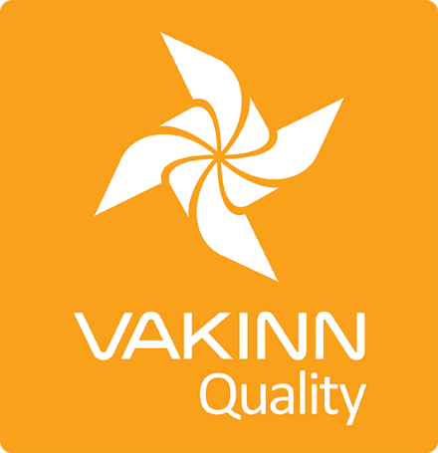

Information Centres

Specific Quality Criteria no. 222 - Checklist

4th edition 2018

Self assessment



**In 4th edition the specific quality criteria is based on self-assessment checklists that applicants/participants complete themselves. The applicable criteria must be completely fulfilled. A clear explanation of how each criterion is fulfilled must be given with reference to appropriate documentation e. g. employee handbook/quality manual, safety plans, photos etc. Random and/or selected criteria will be verified by the auditor.**

|  |  |  |  |  |
| --- | --- | --- | --- | --- |
| ***222-1*** | ***Safety*** | ***Yes*** | ***N/A*** | ***How fulfilled/explanation*** |
| *222-1.1* | The company has written safety plans covering all services offered to customers. |  |  |  |
| *222-1.2* | Safety plans are reviewed at least once a year. |  |  |  |
| *222-1.3* | Employees are briefed on safety plans every year. The briefing is done according to a written procedure. |  |  |  |
| *222-1.4* | The company ensures that employees operate according to safety plans. This is for example stated in employment contracts and subcontracting agreements. |  |  |  |
| *222-1.5* | Tourist services/suppliers that are promoted at the information centre but are not members of Vakinn are informed on the importance of safety plans. This is done according to a written procedure. |  |  |  |
| ***222-2*** | ***Service and Information*** | ***Yes*** | ***N/A*** | ***How fulfilled/explanation*** |
| *222-2.1* | The name of the information centre is stated when answering the telephone. |  |  |  |
| *222-2.2* | Telephones are answered as quickly as possible during opening hours, and an answering machine takes over if calls cannot be answered right away. |  |  |  |
| *222-2.3* | The centre has an answering machine outside office hours that provides information on opening hours in both Icelandic and English. |  |  |  |
| *222-2.4* | Opening hours are advertised and are clearly visible outside the centre and on the centre‘s home page. |  |  |  |
| *222-2.5* | The information centre is clearly marked on the outside. |  |  |  |
| *222-2.6* | For the convenience of travellers after opening hours, a well-lit information board is outside the centre (this may be in a window). This information must be at least in Icelandic and English and include:   1. Opening hours and emergency number. 2. Map of the area where that is possible. c. 3. Other information that may be useful for travellers. |  |  |  |
| *222-2.7* | The information centre is registered in the database of the Icelandic Tourist Board. |  |  |  |
| *222-2.8* | Information is only provided on companies and parties holding the required qualifications and licences for their operations. |  |  |  |
| *222-2.9* | The centre provides comprehensive local and regional information. |  |  |  |
| *222-2.10* | The centre provides booklets from all parts of the country, e.g. from regional marketing offices. |  |  |  |
| *222-2.11* | Booklets are displayed in good quality display racks that are kept well stocked and tidy. |  |  |  |
| *222-2.12* | Employees at the centre speak at least Icelandic and English*.* |  |  |  |
| *222-2.13* | Accessibility and facilities for all persons are kept in mind (i.e. for all age groups, people with restricted mobility, visual or hearing impaired among others). |  |  |  |
| *222-2.14* | The Centre should be open at least:   1. September through May - on average 4 hours a day 2. June, July and August – on average 8 hours a day. |  |  |  |
| *222-2.15* | Managers check that all information the centre displays or provides for travellers are reliable and of good quality. |  |  |  |
| *222-2.16* | There is no preference shown for providers of tourism services regarding facilities to promote their service and care is taken to remain neutral when passing on information. |  |  |  |
| *222-2.17* | Visitors are reminded of responsible behaviour towards nature. |  |  |  |
| *222-2.18* | Correct and up to date information on weather and travelling conditions are available and clearly displayed. Details of precipitation and wind are especially important. |  |  |  |
| *222-2.19* | If the operator of the centre also runs tourist services of a different type, e.g. organised tours or accommodation, competing companies must none the less be able to promote their services in the centre. |  |  |  |
| *222-2.20* | If the operator of the centre runs other types of tourist services, this must be displayed in the centre‘s reception area, on the centre‘s web site or in other promotional materials. |  |  |  |
| ***222-3*** | ***Facilities*** | ***Yes*** | ***N/A*** | ***How fulfilled/explanation*** |
| *222-3.1* | Clean public toilets are on the premises or within a distance of 500 meters. |  |  |  |
| *222-3.2* | The centre has good external and internal lighting. |  |  |  |
| *222-3.3* | Seating is provided for guests in or by the centre. |  |  |  |
| *222-3.4* | The centre is clearly identified as a service centre for tourists, appropriate road signs, according to current laws and regulations are used. |  |  |  |
| *222-3.5* | Written cleaning plans for scheduled daily cleaning and general long term cleaning are in place. The plans cover all areas of the facilities, indoors as well as outdoors. |  |  |  |
| ***222-4*** | ***Education and Training*** | ***Yes*** | ***N/A*** | ***How fulfilled/explanation*** |
| *222-4.1* | All employees are given the opportunity to attend courses intended for those that provide tourist information. |  |  |  |
| *222-4.2* | The Icelandic Tourist Board database has been introduced to the employees. |  |  |  |
| *222-4.3* | Employees understand and are able to explain what Vakinn stands for and how the system benefits travellers. |  |  |  |