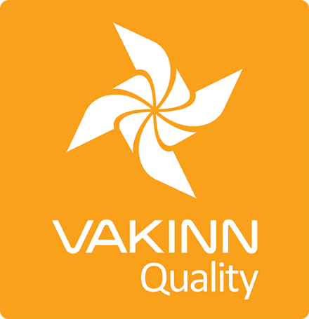

Museums, Centres and Exhibitions
Specific Quality Criteria no. 213 - Checklist

4th edition 2018
Self assessment

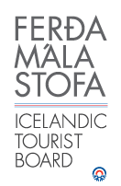
In 4th edition the specific quality criteria is based on self-assessment checklists that applicants/participants complete themselves. The applicable criteria must be completely fulfilled. A clear explanation of how each criterion is fulfilled must be given with reference to appropriate documentation e. g. employee handbook/quality manual, safety plans, photos etc. Random and/or selected criteria will be verified by the auditor.
213-1 | Safety | Yes | N/A | How fulfilled/explanation
213-1.1 | The company has written safety plans covering all services offered to customers.
213-1.2 | Safety plans are reviewed at least once a year.
213-1.3 | Staff members are briefed on safety plans every year. The briefing is done according to a written procedure.
213-1.4 | The company ensures that staff members operate according to safety plans. This is for example stated in employment contracts and subcontracting agreements.
213-2 | Information and Services | Yes | N/A | How fulfilled/explanation
213-2.1 | Opening hours are clearly advertised.
213-2.2 | The advertised opening hours and times of events are adhered to.
213-2.3 | Information are accessible and clearly presented in at least one language other than Icelandic.
213-2.4 | Accessibility for all people is kept in mind (i.e. for all age groups, persons with restricted mobility, visual or hearing impaired among others).
213-2.5 | Customers are reminded of responsible behaviour towards the environment.
213-3 | Operation Practices | Yes | N/A | How fulfilled/explanation
213-3.1 | Manager and/or service provider is familiar with current Acts and Regulations on archaeology and artefacts relevant to the operation.
213-3.2 | Protection is kept in high regard and the protection of cultural artefacts is emphasised as a key factor in all operations cf. the current Act on Protection of Cultural Heritage. This applies to tangible as well as intangible facets of cultural heritage. This implies among other:  - Meticulously define the value of the place/artefact/factor from a cultural-history point of view.  - To raise interest and awareness in communities/societies or among others with vested interest by consulting with them.  - Cooperating with specialists on developing a conservation plan/strategy that complies with current laws and recognised conservation practices (e.g. laws and regulations on the conservation of cultural heritage).
213-3.3 | Those in charge of museums must abide by laws and recognised working methods pertaining to museum operations (see e.g. Current Act on Museums and ICOM‘s Code of Ethics).
213-3.4 | Museums and exhibitions are well maintained, signs and labels are tidy and legible and exhibits are properly positioned.
213-3.5 | The contents of exhibitions are reviewed regularly in cooperation with specialists or authorities within the relevant field.
213-3.6 | The history and the relevant topic are held in high regard, keeping in mind integrity, authenticity and truthfulness in all presentation.
213-3.7 | An effort is made to ensure that all presentation is professional, diverse and of high quality, suitable for diverse groups. Potential review and development of presentation and communication is kept in mind.
213-3.8 | An effort is made to offer lively and interactive presentations e.g. guidance and events among other.
213-3.9 | Written cleaning plans for scheduled daily cleaning and general long term cleaning are in place. The plans cover all areas of the facilities, indoors as well as outdoors.
213-4 | Education and Training | Yes | N/A | How fulfilled/explanation
213-4.1 | Employees have specialist education, e.g. are specialists in the appropriate field, certified guides and/or experienced in the field of history and culture.
213-4.2 | At least one employee on each work shift has completed basic first aid course (4 hours) from a certified trainer and attends a refresher course every two years.

