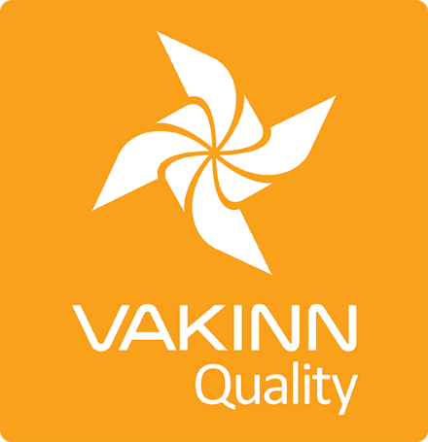

Travel Agencies
Specific Quality Criteria no. 211 - Checklist

4th edition 2018
Self assessment

In 4th edition the specific quality criteria is based on self-assessment checklists that applicants/participants complete themselves. The applicable criteria must be completely fulfilled. A clear explanation of how each criterion is fulfilled must be given with reference to appropriate documentation e.g. employee handbook/quality manual, safety plans, photos etc. Random and/or criteria will be verified by the auditor.
211-1 | Safety | Yes | N/A | How fulfilled/explanation
211-1.1 | The company has written safety plans covering all tours and services offered to customers.
211-1.2 | Safety plans are reviewed at least once a year.
211-1.3 | Employees are briefed on safety plans every year. The briefing is done according to a written procedure.
211-1.4 | The company ensures that employees operate according to safety plans. This is for example stated in employment contracts and  subcontracting agreements.
211-1.5 | The company ensures that contingency plans are at hand on every  tour.
211-1.6 | The company gathers information on safety plans of suppliers. This is done according to a written procedure.
211-1.7 | Customers are reminded of responsible behaviour towards the environment.
211-2 | Cooperation with Suppliers/Partners | Yes | N/A | How fulfilled/explanation
211-2.1 | The company verifies that suppliers have all necessary licenses for their services. This is done according to a written procedure.
211-2.2 | As a rule, the company visits suppliers and service providers to learn how their operations are conducted.
211-2.3 | The travel agency has written procedures on how to respond to changes in products or services that are provided by suppliers and partners.
211-2.4 | The travel agency emphasizes doing business with accommodations that have been verified by Vakinn or another independent quality control system.
211-2.5 | The travel agency emphasizes doing business with activity providers that have been verified by Vakinn or another independent quality control system.
211-2.6 | Regular surveys are conducted among the clients to check their opinions on the performance of suppliers and service providers; ideas on how performance could be improved are forwarded when required.
211-2.7 | The travel agency requires that all vehicles provided by suppliers/service providers must be up to the standards of Vakinn quality criteria.
211-2.8 | The travel agency introduces the Vakinn quality system to Icelandic cooperating parties and encourages them to obtain a quality certification from Vakinn or another recognised quality control system.

