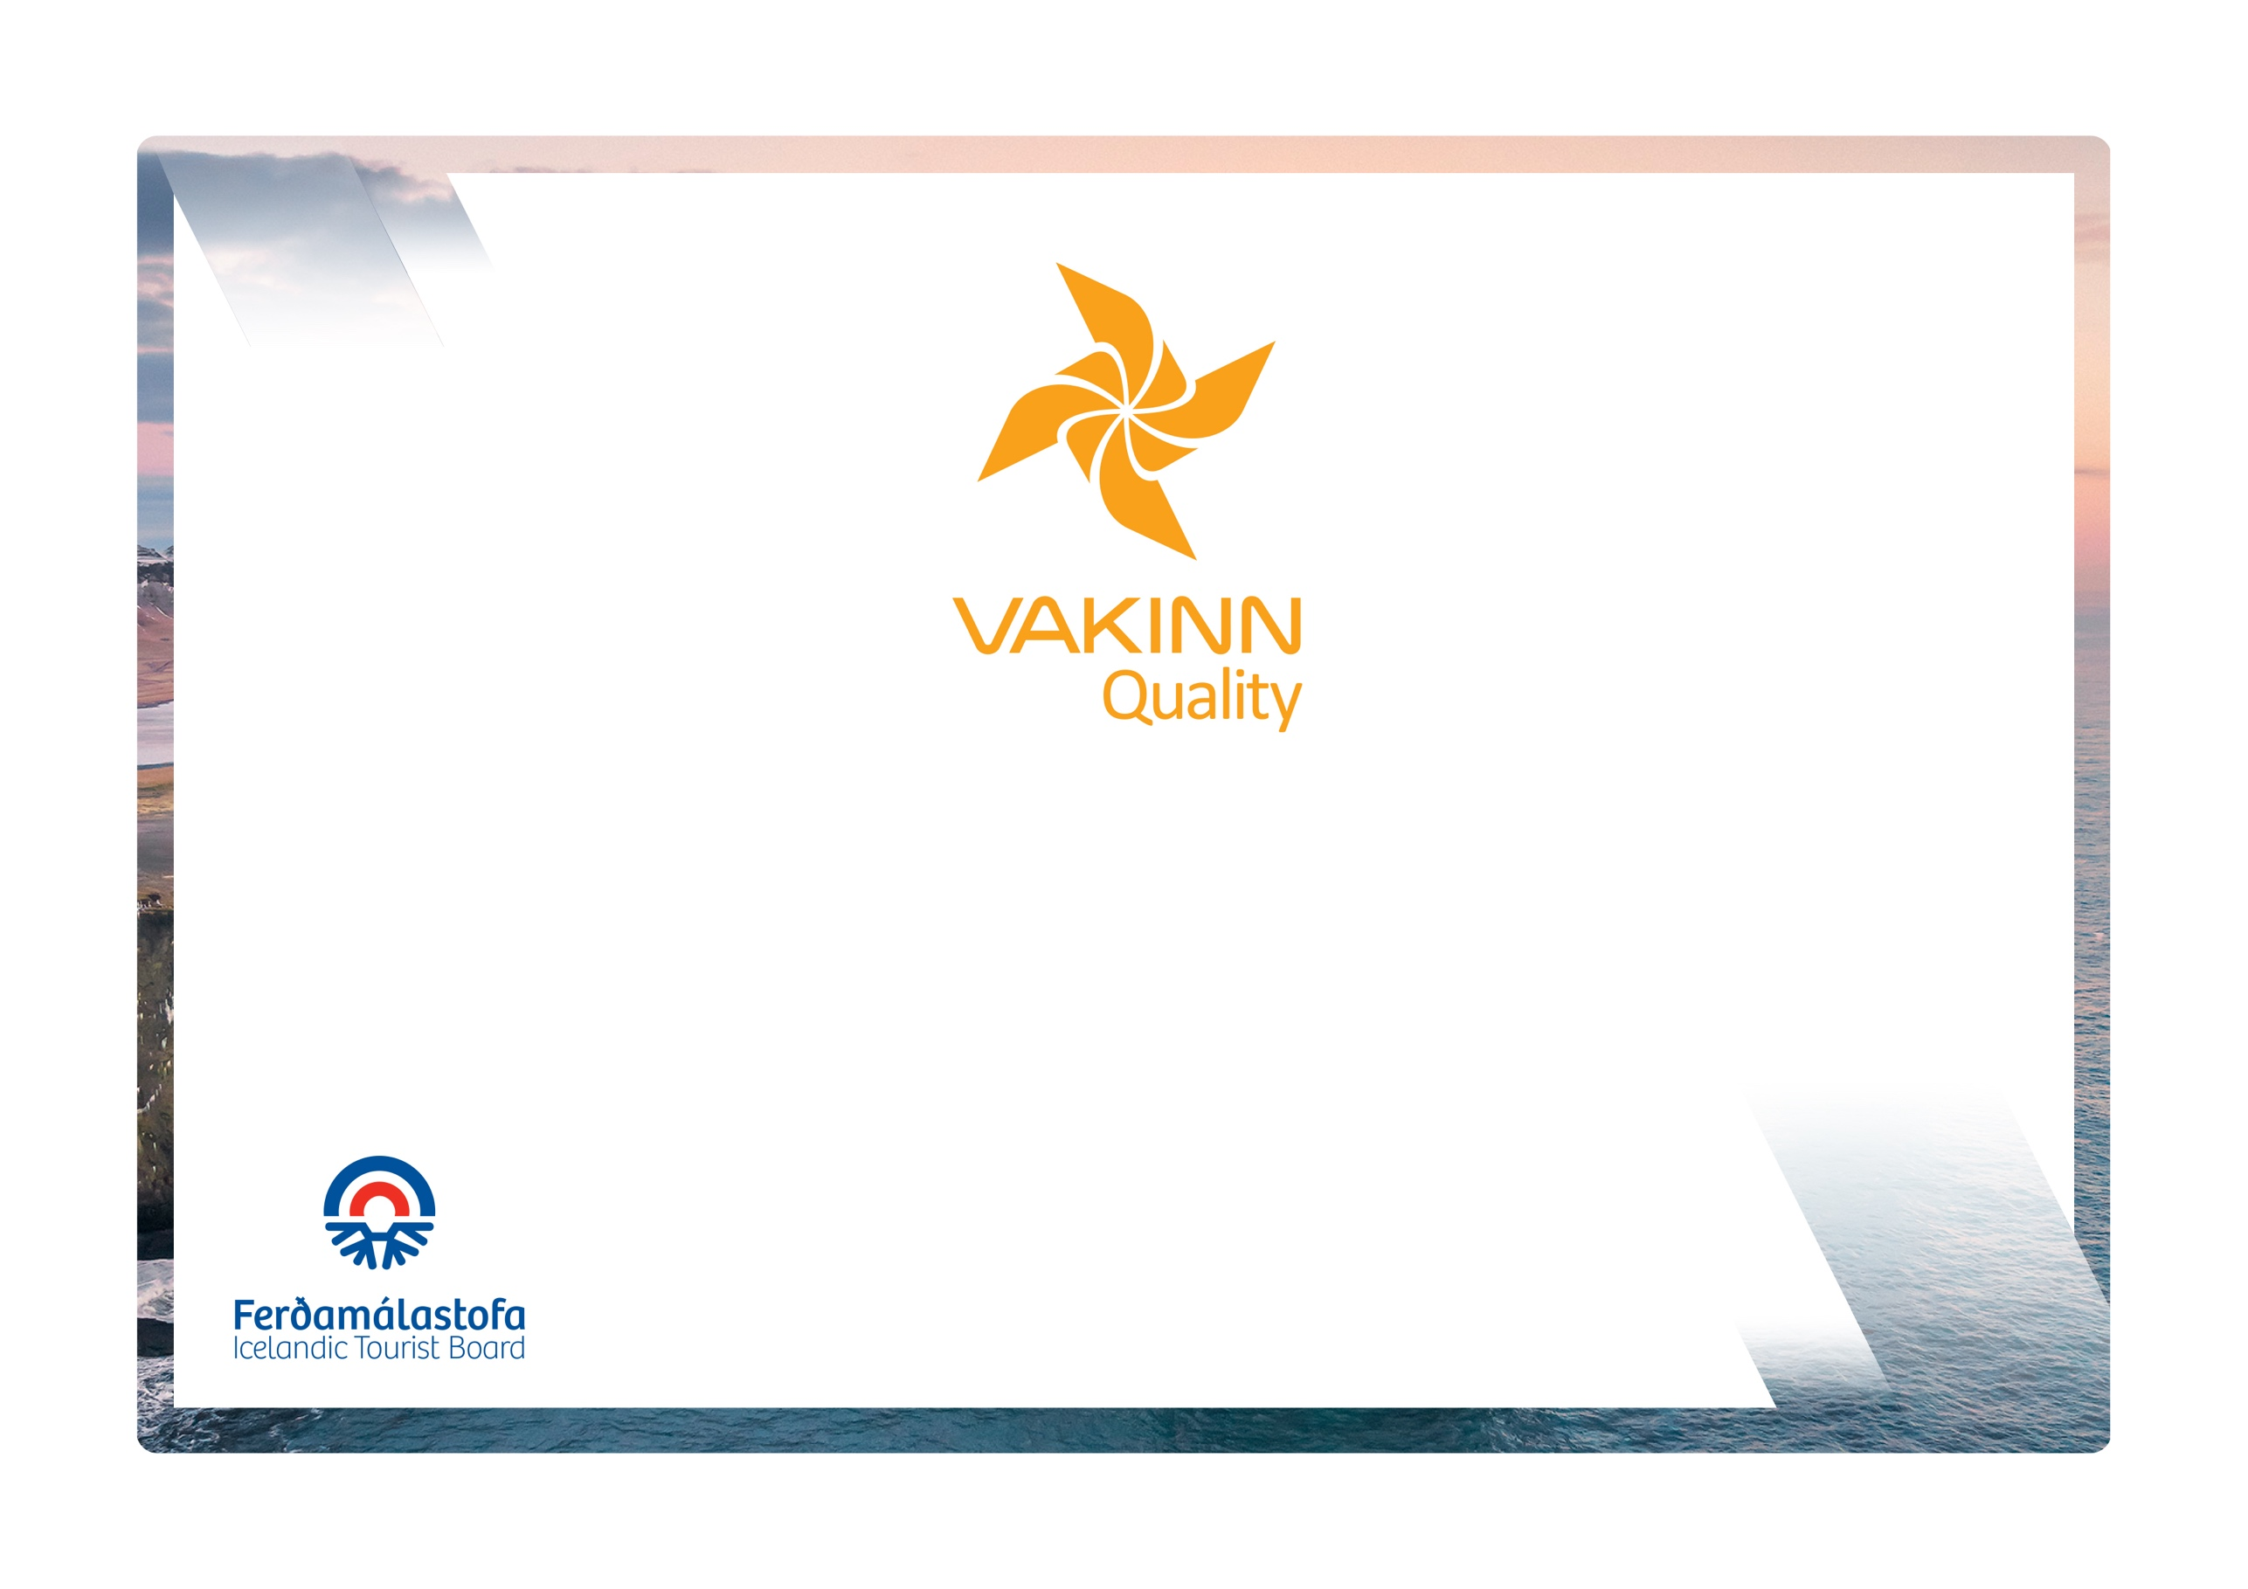

Quality Criteria for Guesthouses

Quality and Environmental Certification
On the Way to Sustainable Tourism

4th edition 2023

Table of Contents

1. Immediate Surroundings 3
1.1 Exterior appearance 3
2. Safety 3
2.1 Lighting, fire protection and more 3
3. Common areas 4
3.1 Facilities and furnishings 4
3.2 Reception and employees 4
3.3 Miscellaneous services 5
3.4 Leisure/recreation 5
4. Guestrooms (sleeping quarters) 5
4.1 Facilities and furniture 5
4.2 Beds and bed linen 7
5. Bathrooms and toilet facilities 7
6. Dining facilities and meals 9
6.1 Dining room 9
6.2 Breakfast 9
6.3 Dinner 10
7. Hygiene and cleaning 10
7.1 General hygiene 10
7.2 Hygiene and facilities of guest kitchen (if applicable) 10
8. Education and training of employees 11
9. Accessibility for the disabled 12

The following quality criteria are filled out by a company representative and sent to the auditor along with other documents. A clear explanation of how each applicable criterion is fulfilled must be given with reference to appropriate documentation, e. g. employee handbook/quality manual, safety plans, photos etc. Random and/or selected criteria will be verified by the auditor. Quality criteria marked (N) are new from previous edition.
Criteria marked in red are minimum requirements and must be fulfilled.
Immediate Surroundings |  | Yes | No | How fulfilled/explanation

1.1 Exterior appearance
1.1.1 | All signs, markings and flags are in good condition.
1.1.2 | Outdoor lighting is sufficient, e.g. at parking lots, walkways, steps, entrances, etc. Careful attention is paid to the maintenance of these areas all year round.
1.1.3 | Inviting outdoor premises e.g. sheltered areas (separated area; a porch or terrace), garden furniture, and flower beds/pots etc.
1.1.4 | Charging stations for electric cars are available for guests on site. (N)
Safety |  | Yes | No | How fulfilled/explanation

2.1 Lighting, fire protection and more
2.1.1 | Common areas e.g. hallways and stairwells are well lit to ensure the comfort and safety of guests.
2.1.2 | Smoke detectors are in all guestrooms, hallways and other common areas. They are tested regularly.
2.1.3 | Gas detector is in the guest kitchen, if applicable.
2.1.4 | Fire extinguishers are on site, tested reglulary and staff trained to use them.
2.1.5 | Drawings showing emergency exit routes are prominently displayed in all guestrooms.
2.1.6 | Emergency lighting.
2.1.7 | Unhindered access to emergency exits.
2.1.8 | Clear and appropriate information regarding safety, e.g. 112 emergency number for Iceland, safety in and around hot tubs, doctor on call number etc., are displayed in guestrooms or common areas.
2.1.9 | First aid kit is in place, checked and restocked regularly.
2.1.10 | Guest rooms can be locked from the inside (private rooms).
2.1.11 | Fire blanket and fire extinguisher are in place in the guest kitchen, if applicable.
2.1.12 | A defibrillator is on site.
Common areas |  | Yes | No | How fulfilled/explanation

3.1 Facilities and furnishings
3.1.1 | Lounge / library separated from reception area and dining room. Furniture, equipment and fixtures are in a very good condition, little signs of wear and tear.  Appropriate lighting.
3.1.2 | TV is in lounge or other common area.

3.2 Reception and employees
3.2.1 | Reception is clearly marked and identified.
3.2.2 | Reception is staffed during peak arrival and departure hours.
3.2.3 | Employees can be reached by phone 24 hours.
3.2.4 | Reception is staffed 14 hours a day.
3.2.5 | Night security guard.
3.2.6 | Luggage service on demand.

3.3 Miscellaneous services
3.3.1 | Wireless internet access in common areas.
3.3.2 | Safe Travel information screen.
3.3.3 | Drinks can be bought.
3.3.4 | Alcoholic beverages can be bought (liquor licence).
3.3.5 | Ice cubes are available.
3.3.6 | Snacks can be bought, e.g. chips, nuts, and chocolate.
3.3.7 | Guests have access to laundry facilities (washer and dryer).
3.3.8 | Laundry service on demand, return within 24 hours.
3.3.9 | Locked luggage room.
3.3.10 | Safekeeping facilities at the reception (a safe deposit box).

3.4 Leisure/recreation
3.4.1 | Facilities for leisure activities e.g. table top football, billiard.
3.4.2 | Play area for children e.g. indoor play corner or outdoor play equipment.
3.4.3 | Books/table top games for the use of guests.
3.4.4 | Hot tub with safe access. Information and guidelines for guests are clearly displayed.
3.4.5 | Bicycles can be rented on site.
Guest rooms (sleeping quarters) |  | Yes | No | How fulfilled/explanation

4.1 Facilities and furniture
4.1.1 | Furniture, equipment and fixtures are in a very good condition, little signs of wear and tear.
4.1.2 | Sufficient floor space and doors can be fully opened.
4.1.3 | Adjustable heating is in rooms.
4.1.4 | At least one window is in each room, in case the window cannot be opened good ventilation/air-conditioning is required.
4.1.5 | Curtains to completely darken the room (black out curtains).
4.1.6 | Clothes hooks/clothes shelves.
4.1.7 | Bedside table/shelf.
4.1.8 | Good room lighting.
4.1.9 | Reading light is by the bed.
4.1.10 | One chair in the room.
4.1.11 | Wastebasket is in the room and information on the company’s waste sorting visible. (N)
4.1.12 | Accessible power socket(s) is in the room.
4.1.13 | Clothes rack/wardrobe with matching hangers. Simple wire hangers are not sufficient.
4.1.14 | Luggage shelf or rack.
4.1.15 | Bedside table/shelf is at each bed.
4.1.16 | Table (other than bedside table).
4.1.17 | Individual reading light is next to each bed.
4.1.18 | One seat/chair is per bed.
4.1.19 | One comfortable (upholstered) chair or couch.
4.1.20 | Mirror in the room.
4.1.21 | TV is in appropriate size for the room.
4.1.22 | Iron and ironing board, on demand.
4.1.23 | Tea and coffee in rooms (tea, coffee, sugar, sweetener and milk/dried milk).
4.1.24 | Internet access in rooms.
4.1.25 | Detailed information/service manual in the room listing services offered (at least in Icelandic and English).

4.2 Beds and bed linen
4.2.1 | Well-kept and clean mattresses in good condition, minimum 13 cm.
4.2.2 | Single beds, minimum size 0,90 x 2,00 and double bed, minimum size 1,60m x 2,00m.
4.2.3 | Hygienic covers are on all mattresses.
4.2.4 | Well kept and clean duvets and pillows.
4.2.5 | Well-kept and clean bed linens.
4.2.6 | Single beds, minimum size 0,90m x 2,00m and double beds, minimum size 1,60m x 2,00m.
4.2.7 | Single beds, minimum size of 0,90m x 2,00m and double beds, minimum size of 1,80m x 2,00m
4.2.8 | Single beds, minimum size of 1,00m x 2,00m and double beds, minimum size of 2,00m x 2,00m.
4.2.9 | Well-kept and clean mattresses are in good condition, minimum 18 cm.
4.2.10 | Additional pillow on demand.
4.2.11 | Blanket (throw), on demand.
4.2.12 | Crib on demand.
Bathrooms and toilet facilities |  | Yes | No | How fulfilled/explanation
5.1 | Shared bathroom facilities are clearly identified.
5.2 | Floors, walls and ceilings are clean and in good condition.
5.3 | Washbasin is in all rooms. (Applicable to rooms with shared facilities).
5.4 | At least one WC for every ten guests. (Applicable to rooms with shared facilities).
5.5 | Shower curtain/door.
5.6 | At least one shower and/or bathtub for every ten guests. Where more than one shower is in the same room, they must be separated by a partition. (Applicable to rooms with shared facilities).
5.7 | Bathrooms can be locked from inside.
5.8 | Adequate ventilation, fan or hinged/flip up window.
5.9 | Opaque glass, film or curtains are in windows to ensure the privacy of guests.
5.10 | Adequate lighting is at the washbasin and in the ceiling.
5.11 | Wastebasket.
5.12 | Mirror is at the washbasin.
5.13 | Accessible power socket is near the mirror.
5.14 | Shelf for toiletries is by the washbasin.
5.15 | Towel rails or towel hooks.
5.16 | Toilet paper in reserve.
5.17 | Two towels are per guest, (one hand towel and one bath towel).
5.18 | Body wash or shower gel is at the shower/bathtub.
5.19 | One glass is per guest.
5.20 | Hairdryer, on demand.
5.21 | Washable bath mat (fabric).
5.22 | All rooms have private shower (bathtub) and WC.
5.23 | Slip prevention is in shower/bathtub.
5.24 | Safety handles are in or by the shower/bathtub.
5.25 | Heated towel rails/rack.
5.26 | Hairdryer is in all rooms with private bathrooms.
5.27 | Bathrobe, on demand.
Dining facilities and meals |  | Yes | No | How fulfilled/explanation

6.1 Dining room
6.1.1 | Tables and chairs are in good condition.
6.1.2 | Window curtains (cloth, blinds, screen or film), where needed.
6.1.3 | Good lighting.
6.1.4 | High chair, on demand.

6.2 Breakfast
6.2.1 | Light breakfast is offered (coffee/tea, juice, water, milk, bread, butter, two types of toppings, one type of cereal). Self-service.
6.2.2 | Light breakfast is served (coffee/tea, juice, water, milk, bread, butter, two types of toppings, one type of cereal).
6.2.3 | Breakfast buffet or equivalent breakfast menu card. Wide selection and attractively presented e.g. coffee/tea, fruit juice, water, milk, fruit, at least three types of cereals, cheese and other toppings at least three types, bread/rolls at least three varieties, crispbread and crackers at least three varities jams/marmalades and something sweet (pastries) (food stored at correct temperatures/chilled).)
6.2.4 | Warm foods; eggs/scrambled eggs, bacon/sausages, baked beans etc. (at least two varieties foods kept warm).
6.2.5 | Regional kitchen, at least three types of local food products, labelled as such.

6.3 Dinner
6.3.1 | Dinner (at least course of the day) served for at least two hours in the period 18:00-22:00 (must be advertised).
6.3.2 | Buffet or menu of the house.
6.3.3 | Regional kitchen, significant part of used products are from the region, the origin must be known and explained to guests.
Hygiene and cleaning |  | Yes | No | How fulfilled/explanation

7.1 General hygiene
7.1.1 | Very high standard of cleanliness and hygiene: No dirt found, not even with a fingertip test on picture frames, doorframes and lamps. Bath/shower and toilet fixtures are clean and free from lime scale. Shower curtains are clean.
7.1.2 | Daily room cleaning/checking of guest rooms; this includes cleaning floors, emptying wastebaskets, changing glasses, making beds and changing towels according to the guest’s wishes.
7.1.3 | Daily change of towels on demand. To protect the environment guests are encouraged to use towels more than once.
7.1.4 | Change of bed linens at least once a week for longer stays.
7.1.5 | All common areas are checked/cleaned daily, e.g. hallways, dining facilities, lounges, reception and shared bathrooms and WCs.

7.2 Hygiene and facilities of guest kitchen (if applicable)
7.2.1 | Furniture and fixtures are in good condition.
7.2.2 | Flatware, glassware, cutlery and other kitchen utensils are tidy and in good condition.
7.2.3 | Ventilation, fan or a hinged/flip up window.
7.2.4 | Refrigerator is clean and free from unpleasant odours.
7.2.5 | Cupboards and drawers are clean and tidy.
7.2.6 | Tables, cooker and sinks are clean and tidy (may show some signs of wear and tear).
7.2.7 | Where dishwasher or microwave are in the kitchen, these are clean and in good condition.
7.2.8 | Daily change of dishtowels and teacloths.
7.2.9 | House rules for the kitchen are clear and displayed in the kitchen.
Education and training of employees |  | Yes | No | How fulfilled/explanation
8.1 | Employees receive training in the reception of guests. Written description, on how this is performed and what is covered, is available.
8.2 | Employees receive training in cleaning and housekeeping. Written description on how this is performed and what is covered is available.
8.2 | Kitchen employees receive training in the handling of food and proper hygiene.  Written description on how this is performed and what is covered is available.
8.3 | Reception employees receive information about the local environment, e.g. history, culture, recreation and events so they can provide reliable information. Written description on how this is performed and what is covered is available. (N)
8.4 | Employees who do not speak Icelandic are encouraged and supported to learn Icelandic. This is addressed in training for new employees. (N)

Accessibility for the disabled
9.1 | The company participates in the project Accessible Tourism, run by the Icelandic Tourist Board, and has confirmed that minimum criteria regarding accessibility for the disabled is fulfilled.(N)
9.2 | The company participates in the project Accessible Tourism, run by the Icelandic Tourist Board, and has confirmed that minimum criteria regarding accessibility for the visually impaired and the blind is fulfilled. (N)
9.3 | The company participates in the project Accessible Tourism, run by the Icelandic Tourist Board, and has confirmed that minimum criteria regarding accessibility for the hearing impaired and the deaf is fulfilled. (N)

