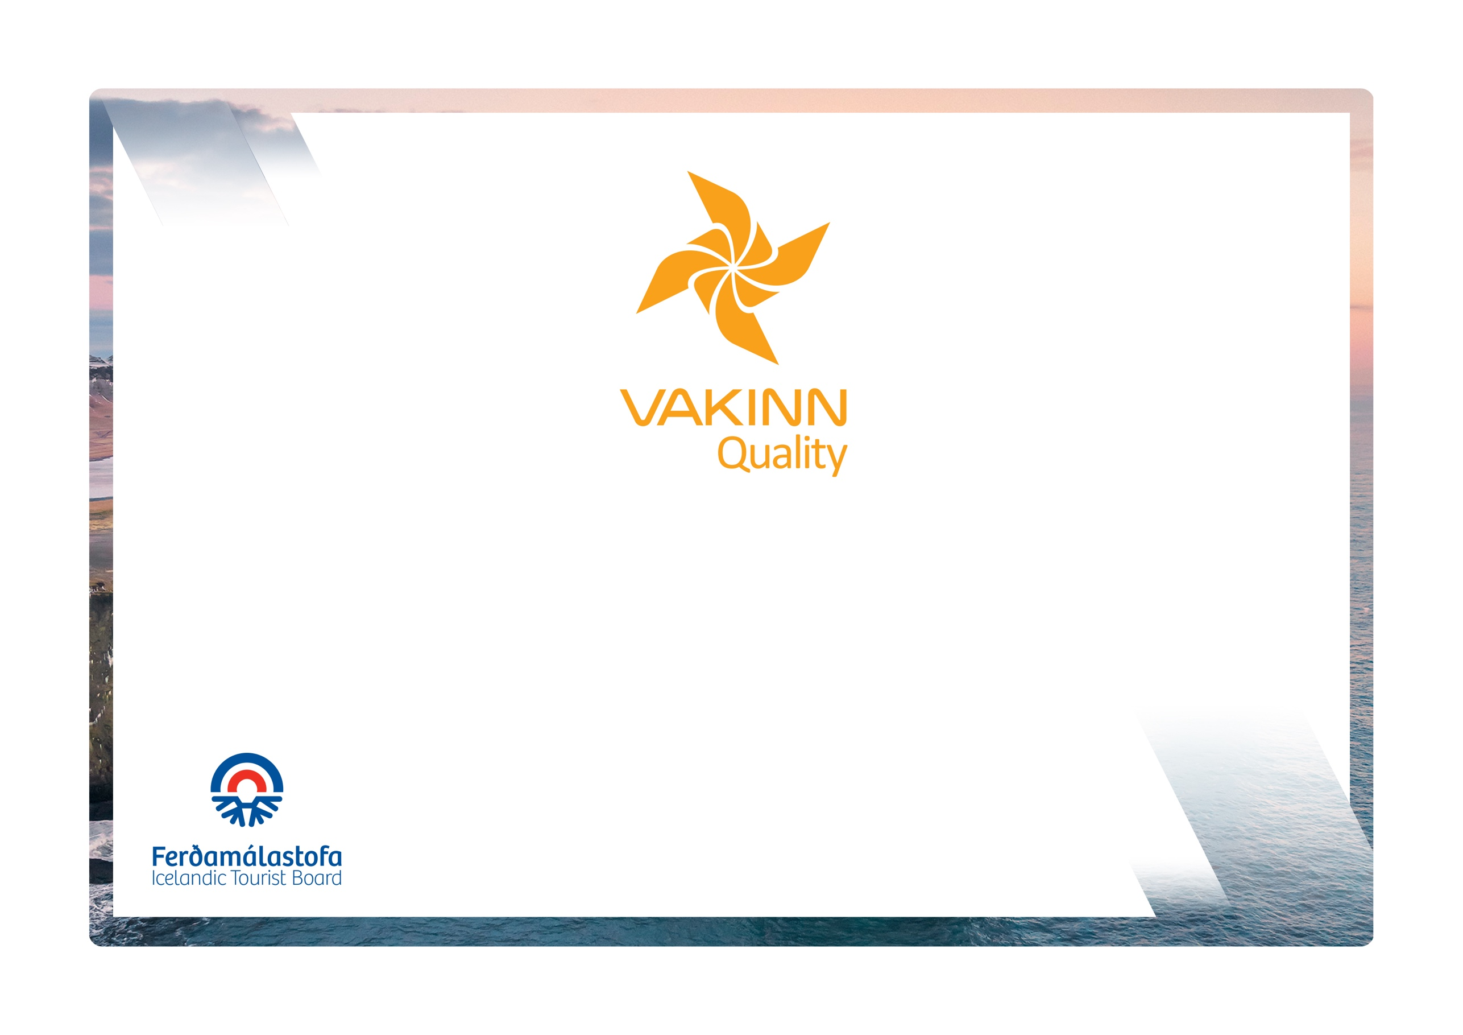

Venues
vakinn.is
Quality and Environmental Certification
On the Way to Sustainable Tourism

Specific Quality Criteria no. 230
5th edition 2022
The following quality criteria are filled out by a company representative. A clear explanation of how each applicable criterion is fulfilled must be given with reference to appropriate documentation, e. g. employee handbook/quality manual, safety plans, photos etc. Random and/or selected criteria will be verified by the auditor.
230-1 | Approach and Public Areas | Yes | N/A | How fulfilled/explanation
230-1.1 | All signs and flags are in good condition.
230-1.2 | All indoors markings are clear and point to different spaces in the building.
230-1.3 | Accessibility for all people is kept in mind (i.e. for all age groups, persons with restricted mobility, visual or hearing impaired among others).
230-1.4 | The following is regularly checked:  - Driveway, steps and paths are safe.  - Indoor and outdoor lighting is sufficient and and all lights are in order.  - Emergency exits are unhindered and they clearly marked.  Employee responsible is defined.
230-1.5 | Reception/service desk is marked and staffed during events.
230-1.6 | Defibrillator is in place in the building.
230-1.7 | Seats are available for guests in public areas.
230-1.8 | Toilets are marked and in impeccable condition.  In the written cleaning plan, cf. criterion no. 200-3.9, a special procedure is specified for cleaning and disinfection of toilets when there are events in the house.
230-1.9 | Wireless internet access in public areas.
230-1.0 | Buildings and facilities have been checked regarding accessibility for all (i. e. for all age groups, persons with restricted mobility, visual or hearing impaired etc.).
230-2 | Facilities and Service for Conferences and Meetings | Yes | N/A | How fulfilled/explanation
230-2.1 | A concierge is in the building during events and is easy to reach.
230-2.2 | A technician is available during events.
230-2.3 | Curtains to completely darken the room are in place.
230-2.4 | Ventilation system is without disturbing noise. Written procedures for using and managing the system are in place. Employee who is responsible is defined.
230-2.5 | The temperature in each room is easy to control.
230-2.6 | Lighting is a minimum of 200 lux.
230-2.7 | A secure and good internet connection is available.
230-2.8 | Furniture and fixtures are in good condition, minimal signs of wear and tear.
230-2.9 | Equipment, e.g. sound system, projector, flipchart, plugs and extension cords are in perfect condition. Written procedures for handling are in place.
230-2.10 | Catering service is on site or refreshments can be ordered.
230-2.11 | Dishes, glasses and other tableware are of high quality and in good condition.
230-2.12 | If disposable food packaging is used, it is recyclable.
230-2.13 | Tap water is offered instead of water in disposable beverage containers
230-2.14 | The company focuses on doing business with suppliers and partners who have a quality and / or an environmental certification.

230-3 | Education and Training | Yes | N/A | How fulfilled/explanation
230-3.1 | Employees in catering services receive instructions and training in food handling according to Vakinn course descriptions or comparable. Written description of how this is performed and what is covered is available. *
230-3.2 | Employees in catering services receive instructions on the importance of hygiene, cleaning and finishing according to Vakinn course descriptions or equivalent. Written description of how this is performed and what is covered is available. *
*If another operator provides catering services, confirmation of the following must be available:
- That the company's employees have received appropriate instruction and training.
- That the company meets the environmental bronze criteria according to Vakinn or comparable.

