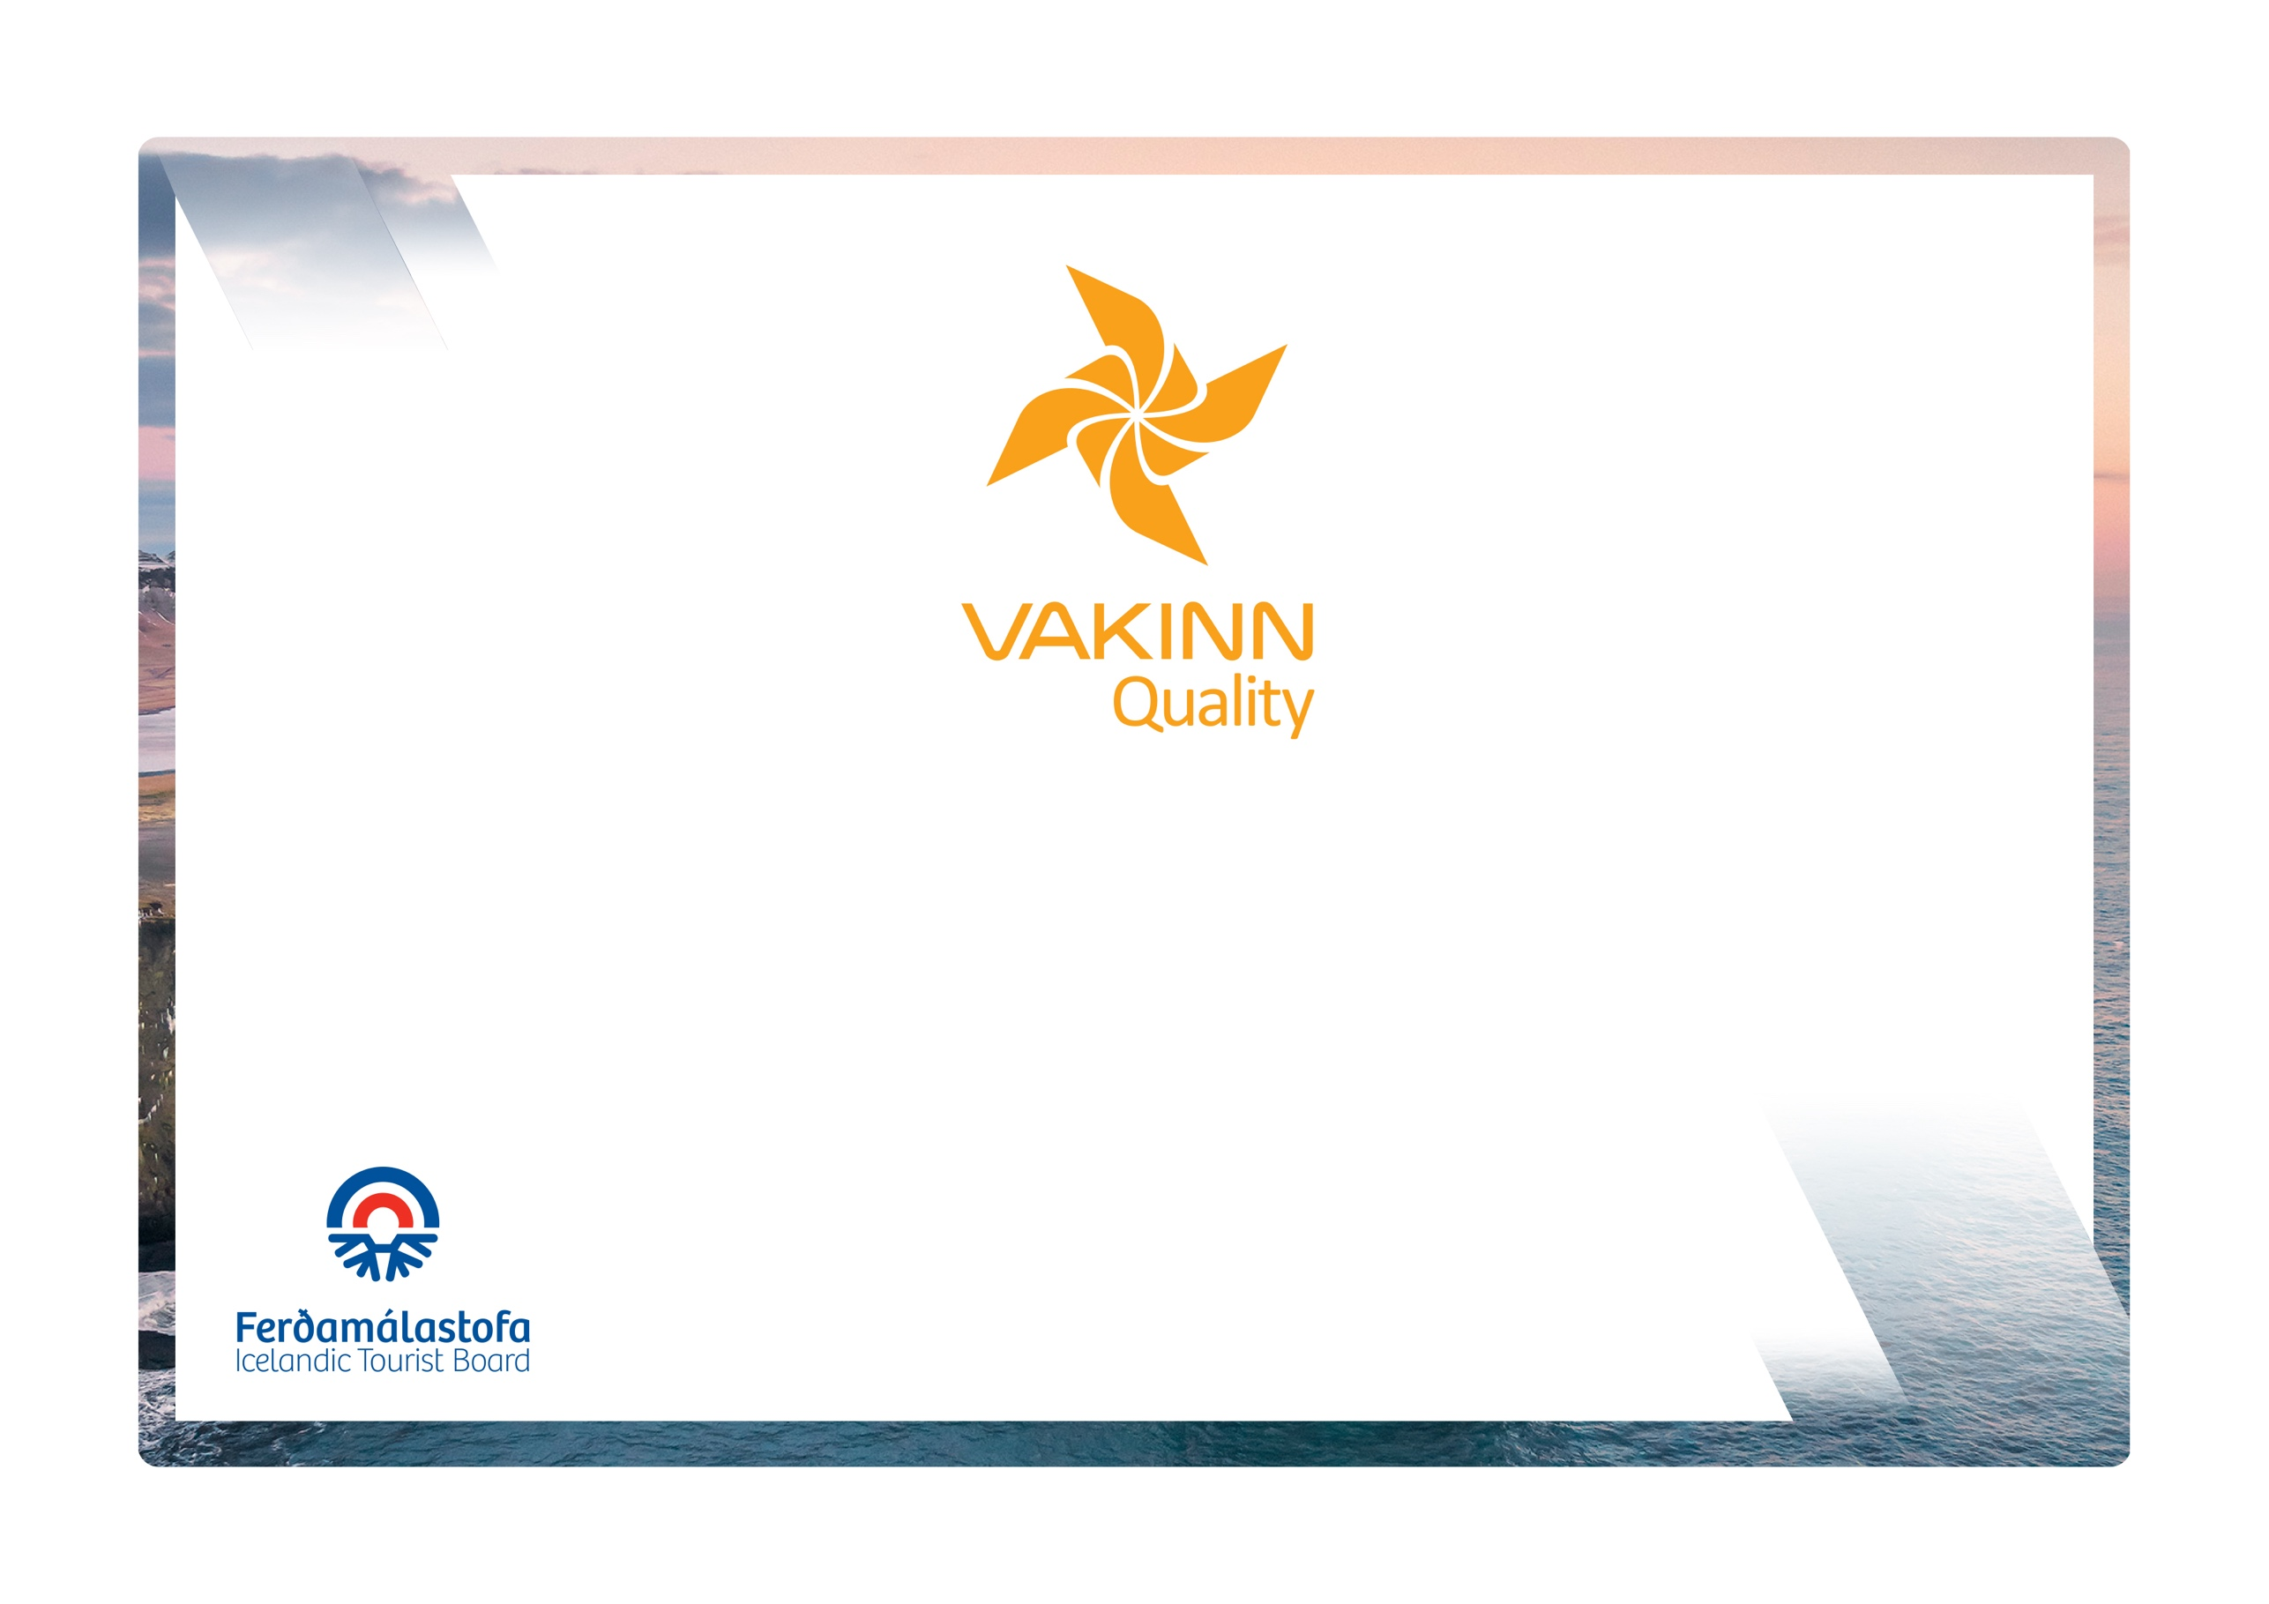
vakinn.is

Information Centres
The following quality criteria are filled out by a company representative. A clear explanation of how each applicable criterion is fulfilled must be given with reference to appropriate documentation, e. g. employee handbook/quality manual, safety plans, photos etc. Random and/or selected criteria will be verified by the auditor.
Quality and Environmental Certification
On the Way to Sustainable Tourism

Specific Quality Criteria no. 222
5th edition 2022
222-1 | Service and Information | Yes | N/A | How fulfilled/explanation
222-1.1 | The name of the information centre is stated when answering the telephone.
222-1.2 | Calls are answered as quickly as possible during opening hours, and an answering machine takes over if calls cannot be answered right away.
222-1.3 | The centre has an answering machine outside office hours that provides information on opening hours in both Icelandic and English.
222-1.4 | Opening hours are advertised and are clearly visible outside the centre and on the centre‘s home page.
222-1.5 | The information centre is clearly marked on the outside.
222-1.6 | For the convenience of travellers after opening hours, a well-lit information board is outside the centre (this may be in a window). This information must be at least in Icelandic and English and include:  - Opening hours and emergency number.  - Map of the area where that is possible.  - Other information that may be useful for travellers.
222-1.7 | The information centre is registered in the database of the Icelandic Tourist Board.
222-1.8 | The information centre provides comprehensive local and regional information.
222-1.9 | If printed brochures are available, they must be well displayed and tidy. Consideration should be given to the environment and possible waste of paper regarding the number of brochures.
222-1.10 | Employees at the information centre speak at least Icelandic and English.
222-1.11 | Buildings and facilities have been checked regarding accessibility for all (i. e. for all age groups, persons with restricted mobility, visual or hearing impaired etc.).
222-1.12 | The centre should be open at least:  - September through May - on average 4 hours a day  - June, July and August – on average 8 hours a day.
222-1.13 | Managers check that all information the information centre displays or provides for travellers are reliable and of good quality.
222-1.14 | There is no preference shown for providers of tourism services regarding facilities to promote their service and care is taken to remain neutral when passing on information.
222-1.15 | Visitors are reminded of responsible travel behaviour and informed, among other things, that all off-road driving is illegal.
222-1.16 | Correct and up to date information on weather and travelling conditions are available and clearly displayed. Details of precipitation and wind are especially important.
222-2 | Facilities | Yes | N/A | How fulfilled/explanation
222-2.1 | Clean public toilets are on the premises or within 500 meters.
222-2.2 | The information centre has good external and internal lighting.
222-2.3 | Seating is provided for guests in or by the information centre.
222-2.4 | The information centre is clearly identified as a service centre for tourists, appropriate road signs, according to current laws and regulations are used.
222-3 | Education and Training | Yes | N/A | How fulfilled/explanation
222-3.1 | All employees are given the opportunity to attend courses intended for those that provide tourist information.
222-3.2 | The Icelandic Tourist Board database has been introduced to the employees.
222-3.3 | Employees have knowledge of the local area and can provide information on nature, culture, history, nature, entertainment and events in the area.  (This is included in written procedures for training of new employees).
222-3.4 | Employees understand and can explain what Vakinn stands for and how the certification benefits travellers.

