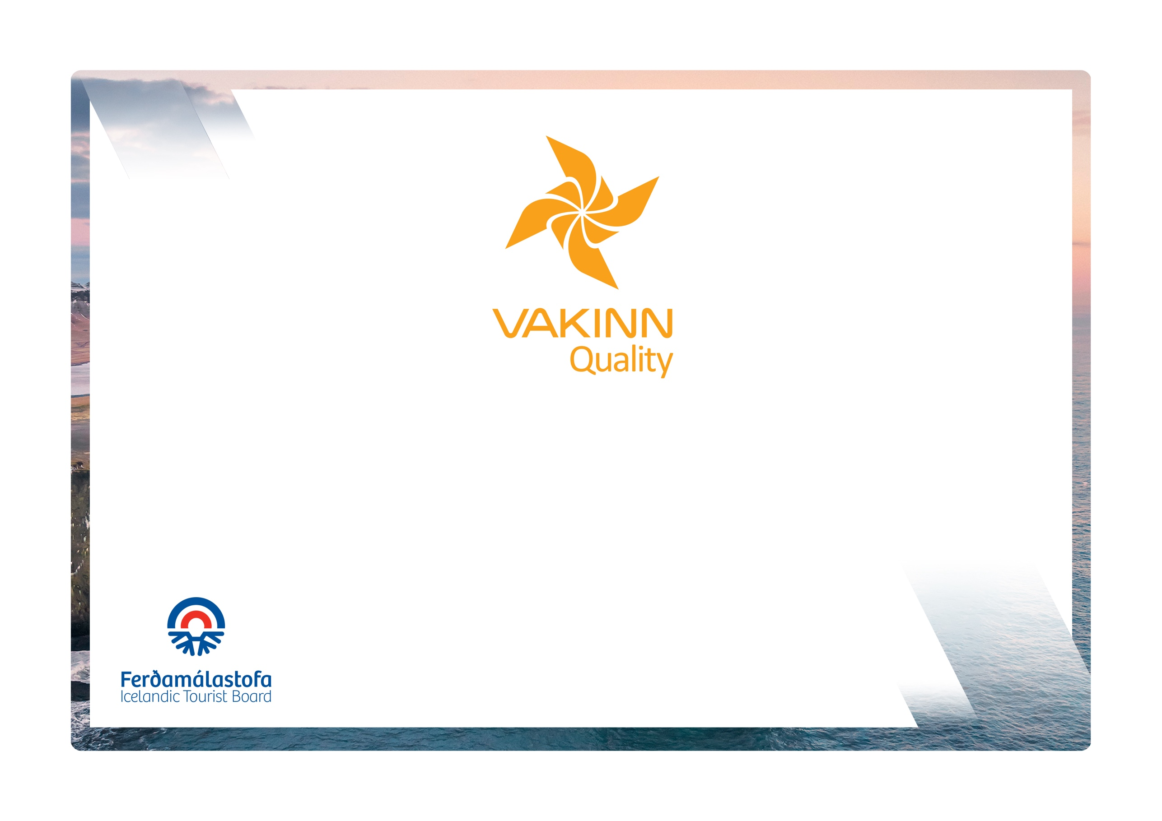

Diving and Snorkelling

vakinn.is
Quality and Environmental Certification
On the Way to Sustainable Tourism

Specific Quality Criteria no. 216
5th edition 2022
The following quality criteria are filled out by a company representative. A clear explanation of how each applicable criterion is fulfilled must be given with reference to appropriate documentation, e. g. employee handbook/quality manual, safety plans, photos etc. Random and/or selected criteria will be verified by the auditor.
216-1 | Safety | Yes | N/A | How fulfilled/explanation
216-1.1 | For each type of tours there is an itinerary (written description) including a description of routes, schedule and other trip arrangements.
216-1.2 | A checklist has been compiled for safety equipment on tours and excursions e.g.:  - First aid kit/equipment.  - Communication devices.  - Oxygen tanks and masks.  - Other equipment according to conditions on each tour.
216-1.3 | A written plan for renewal, cleaning and maintenance of safety  equipment is in place including procedures about i.a.:  - Inspection and testing of equipment.  - Disinfection and cleaning of equipment.  - Lifespan of equipment (see manufacturer's accepted standards).
216-1.4 | All equipment is in a very good condition, i.e.:  - Drysuits are waterproof and wetsuits intact with tight cuffs.  - Belts and straps unbroken.
216-1.5 | All equipment is well and neatly stored after usage. The storage is appropriate and does not reduce the safety and usability of the equipment.
216-1.6 | The company ensures that all customers who take part in diving sessions have a valid diving certificate. (Not applicable for snorkelling).
216-1.7 | Clients are advised on appropriate clothing, additional equipment and other required matters. They also receive information on the facilities available.
216-1.8 | Whenever air-refilling stations are used, care is taken to ensure that all documentation is correctly completed and that regular changing of filters and tests for air pollution have been registered.
216-1.9 | The number of customers per each guide (PADI Dive master) does not exceed 4 for diving and 8 for snorkelling and never exceeds the number allowed according to the rules of the diving site in question.
216-1.10 | To prepare guides for the tours/activities of each day they go through a checklist including the following items, among others:  - Details of the itinerary and routes to be travelled.  - Weather forecast.  - Equipment.  - Information about customers  - That contingency plans are always included / accessible on tours.
216-1.11 | Customers have access to heated facilities for changing into diving suits.
216-1.12 | There is a checklist for guides on the safety matters that are covered with customers before and during the tour, e. g. regarding:  - Information about he intended diving (or snorkelling) excursion, the depth of the dive, length of time spent under water (submerged),  - Local conditions and weather.  - Equipment used during the tour.  - Schedule.  - Safety precautions in situations where special care must be exercised.  - Emergency responses.  - Food, drinks, and access to water during the tour.  - 112 emergency number in Iceland.  It is ensured that customers have understood the instructions.
216-1.13 | All boats used for diving or snorkelling are equipped to meet the needs of divers, e.g. with dice ladders, dive stations and appropriate spare equipment.
216-1.14 | The company has written guidelines on when to cancel tours due to weather. It is clearly stated who decides on the cancellation of tours.
216-1.15 | The company informs employees and customers of the necessity of being in good physical condition and that the use of alcohol or drugs can make them unfit to take part in a tour.
216-2 | Environment | Yes | N/A | How fulfilled/explanation
216-2.1 | Marked roads or recognised vehicle tracks are always used. Off-road driving in winter and on glaciers shall be in accordance with Article 4. of Regulation no. 528/2005 regarding restrictions on traffic in Iceland's nature.
216-2.2 | Streams and rivers are only crossed in designated places and only where wading is considered safe. Where the riverbank is not maintained in terms of wading, damage to the environment shall be prevented as possible.
216-2.3 | Customers are informed about toilet arrangements where conventional facilities are not available.
216-2.4 | All equipment and waste are removed. The company ensures that no permanent traces/damages are seen in the nature in connection with the company’s tours or activities.
216-2.5 | Customers are reminded of responsible travel behaviour f.ex. responsible conduct towards nature in order to protect vegetation, geological formations and wildlife according to regulations in the area.
216-3 | Education and Training | Yes | N/A | How fulfilled/explanation
216-3.1 | Guides have completed the course PADI Dive Master or a comparable course from a certified organisation. They hold a valid licence from the Icelandic Transport Authority as professional divers.
216-3.2 | Guides attend a refresher course in first aid from a certified organisation every year.
216-3.3 | All employees (assistants) participating in tours have completed a first aid course (4 hours) from a recognised organisation and attend a refresher course every two years.
216-3.4 | The head guide is a certified diving instructor holding a licence from a recognised international diving institution such as PADI, SSI or CMAS.

