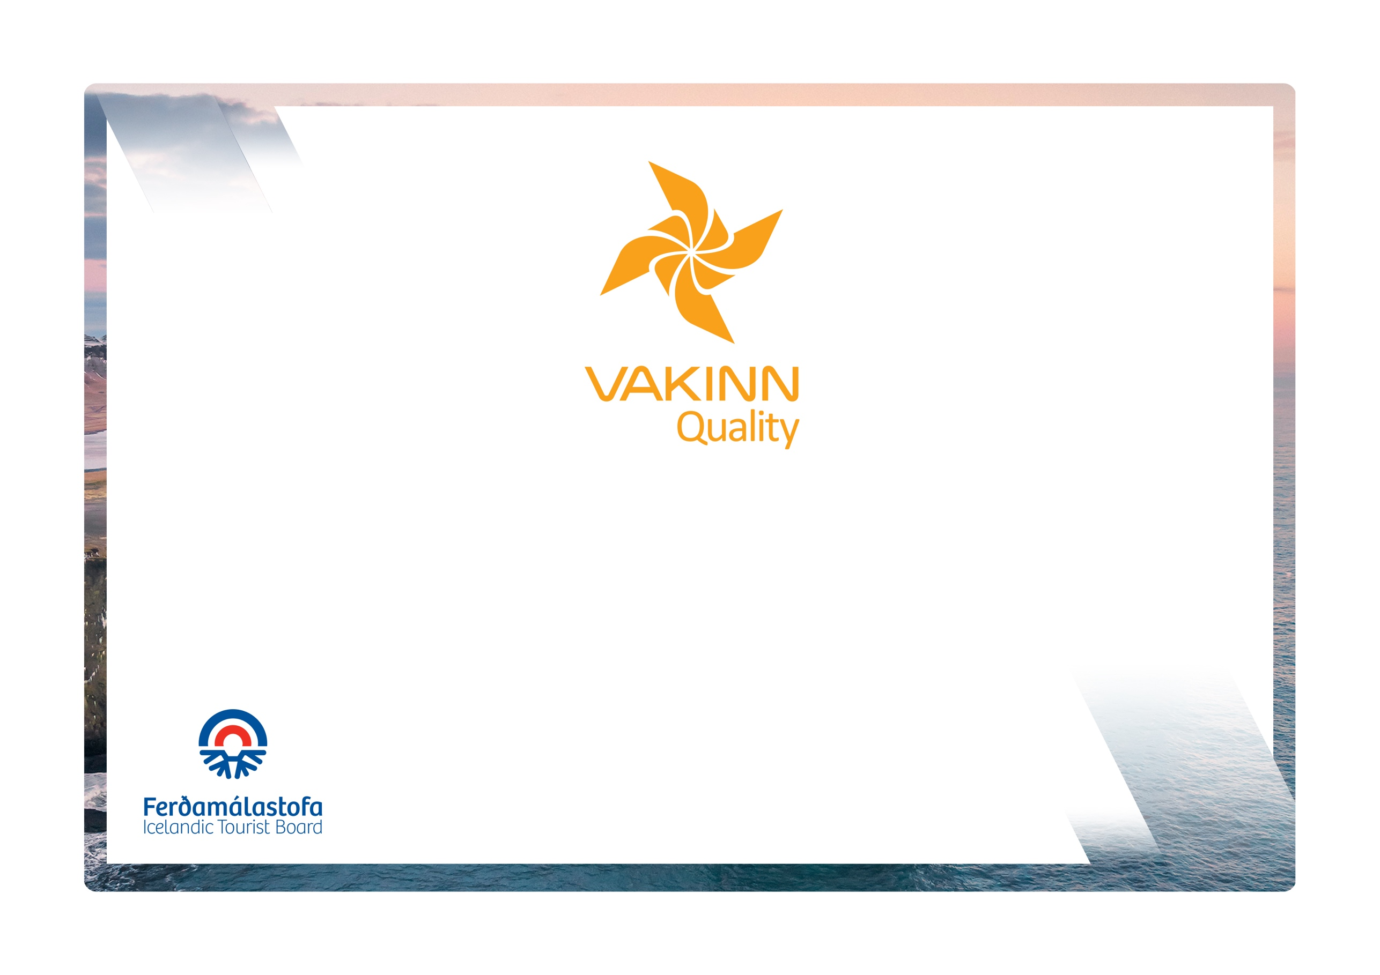
Day Tour Providers and Travel Agencies
vakinn.is

Quality and Environmental Certification
On the Way to Sustainable Tourism

Specific Quality Criteria no. 211
5th edition 2022
The following quality criteria are filled out by a company representative. A clear explanation of how each applicable criterion is fulfilled must be given with reference to appropriate documentation, e. g. employee handbook/quality manual, safety plans, photos etc. Random and/or selected criteria will be verified by the auditor.
211-1 | Safety and Maintenance | Yes | N/A | How
211-1.1 | For each type of tours there is an itinerary (written description) including a description of routes, schedule and other trip arrangements.
211-1.2 | All guides and drivers can easily contact the shift supervisor/immediate supervisor. In tours where no guide / driver is involved, it is ensured that customers can contact the company.
211-1.3 | The company ensures that drivers and guides know where and how to call for assistance if needed, e.g. if a car or a coach needs to be brought to the garage or they need assistance from the police or hospital/healthcare etc.
211-1.4 | The work environment of drivers and guides is assessed and their safety ensured, e.g.:  - Facilities/room for work related gear and protective clothing.  - Sufficient legroom.  - Hands free microphone.  - Rear view mirrors.
211-1.5 | A checklist has been compiled for safety equipment on tours and excursions, including f.ex.:  - First aid kit/equipment.  - Communication devices.  - Tracking devices.  - Extra clothing.  - Other equipment according to conditions on each tour.
211-1.6 | The company has written guidelines on when to cancel tours due to weather. It is clearly stated who decides on the cancellation of tours.
211-1.7 | Vehicles owned or maintained by the company are cleaned and contact surfaces disinfected after each trip according to written procedures.
211-1.8 | A written plan for the maintenance of vehicles, owned or maintained by the company, is in place, detailing daily checks performed by the driver and weekly/monthly/yearly checks performed by the maintenance crew. A maintenance logbook is kept.
211-3 | Cooperation with Suppliers/Partners | Yes | N/A | How fulfilled/explanation
211-3.1 | There is a written procedure on how to verify that appropriate licenses are available from suppliers and partners who are not certified Vakinn, regarding accommodation, transport and entertainment.
211-3.2 | As a rule, the company visits suppliers and partners to learn how their operations are conducted.
211-3.3 | The travel agency emphasizes doing business with companies that have been certified by Vakinn or another independent quality- and environmental system.
211-3.4 | Regular surveys are conducted among the clients to check their opinions on the performance of suppliers and partners. Ideas on how performance could be improved are forwarded when required.
211-3.5 | The company introduces Vakinn to Icelandic partners and encourages them to obtain a quality- and environmental certification from Vakinn and/or another recognised certification
211-4 | Environment | Yes | N/A | How fulfilled/explanation
211-4.1 | Marked roads or recognised vehicle tracks are always used. Off-road driving in winter and on glaciers shall be in accordance with Article 4. of Regulation no. 528/2005 regarding restrictions on traffic in Iceland's nature.
211-4.2 | Streams and rivers are only crossed in designated places and only where wading is considered safe. Where the riverbank is not maintained in terms of wading, damage to the environment shall be prevented as possible.
211-4.3 | The company uses marked rest areas where possible.
211-4.4 | Customers are informed about toilet arrangements where conventional facilities are not available.
211-4.5 | All equipment and waste are removed. The company ensures that no permanent traces/damages are seen in the nature in connection with the company’s tours or activities.
211-4.6 | The company has established clear rules on the idling of vehicle engines.
211-4.7 | Customers are reminded of responsible travel behaviour.

211-5 | Education and Training | Yes | N/A | How fulfilled/explanation
211-5.1 | Drivers and guides have specialized education, e. g. are certified guides and/or have substantial experience appropriate for the tour in question.
211-5.2 | All drivers/driving guides have a valid and appropriate driving license for the vehicles they drive.
211-5.3 | Guides have completed the course Wilderness First Aid (Fyrsta hjálp 1, 20 hours) from ICE-SAR or a comparable course from another organization and attend a refresher course (4 hours) every two years.
211-5.4 | At least one guide/driver on tours through the wilderness* has completed the course Wilderness First Responder (WFR) from ICE-SAR, or a comparable course from another organization, and attends a refresher course every three years.
211-5.5 | Guides/drivers on tours through the wilderness* have substantial experience of driving in the wilderness e. g.:  - Driving on mountain tracks or challenging and difficult routes.  - Crossing rivers.
* Wilderness is a place or area where it takes at least two hours to get assistance/rescue from first responders by land.

