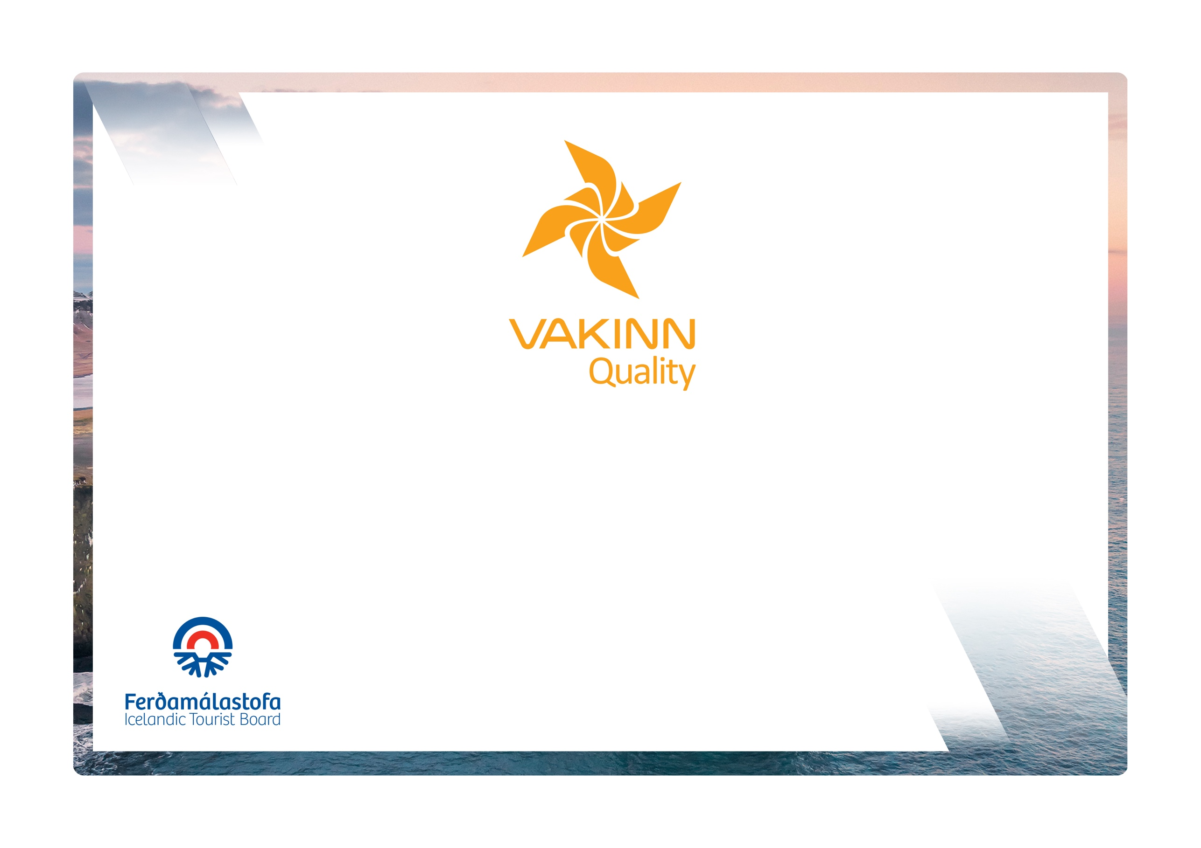

Nature Observation on Land
Quality and Environmental Certification
On the Way to Sustainable Tourism

vakinn.is

Specific Quality Criteria no. 208
5th edition 2022
The following quality criteria are filled out by a company representative. A clear explanation of how each applicable criterion is fulfilled must be given with reference to appropriate documentation, e. g. employee handbook/quality manual, safety plans, photos etc. Random and/or selected criteria will be verified by the auditor.
208-1 |  |  | Safety | Yes | N/A |  | How fulfilled/explanation
208-1.1 |  |  | For each type of tours there is an itinerary (written description) including a description of routes, schedule and other trip arrangements.
208-1.2 |  |  | A checklist has been compiled for safety equipment on tours and excursions, including f.ex.:  - First aid kit/equipment.  - Communication devices.  - Tracking devices.  - Extra clothing.  - Other equipment according to conditions on each tour.
208-1.3 |  |  | A written plan for renewal, cleaning and maintenance of safety  equipment is in place including procedures about i.a.:  - Inspection and testing of equipment.  - Disinfection and cleaning of equipment.  - Lifespan of equipment (see manufacturer's accepted standards).
208-1.4 |  |  | Written rules apply to customer/guide ratio according to conditions on each tour.
208-1.5 |  |  | To prepare guides for the tours/activities of each day they go through a checklist including the following items, among others:  - Details of the itinerary and routes to be travelled.  - Weather forecast.  - Equipment.  - Information about customers  - That contingency plans are always included / accessible on tours.
208-1.6 |  |  | There is a checklist for guides on the safety matters that are covered with customers before and during the tour, e. g. regarding:  - Local conditions and weather.  - Schedule.  - Safety precautions in situations where special care must be exercised.  - Appropriate clothing and equipment.  - Food, drinks, and access to water during the tour.  - 112 emergency number in Iceland.
208-1.7 |  |  | The company ensures that when customers are transported by vehicles (cars, bikes, ATVs, snow mobiles etc.), all regulations concerning licences are adhered to and appropriate safety measures are taken; e.g. use of safety belts, helmets and other safety equipment.
208-1.8 |  |  | The company has written guidelines on when to cancel tours due to weather. It is clearly stated who decides on the cancellation of tours.
208-2 |  | Environment |  | Yes | N/A | How fulfilled/explanation
208-2.1 |  | Marked roads or recognised vehicle tracks are always used. Off-road driving in winter and on glaciers shall be in accordance with Article 4. of Regulation no. 528/2005 regarding restrictions on traffic in Iceland's nature.
208-2.2 |  | Streams and rivers are only crossed in designated places and only where wading is considered safe. Where the riverbank is not maintained in terms of wading, damage to the environment shall be prevented as possible.
208-2.3 |  | The company complies with laws and regulations on environmental protection.
208-2.4 |  | The company observes current laws and regulations on animal protection, such as laws on protection of specific species during nesting or breeding season.
208-2.5 |  | The company has compiled and published a Code of Conduct regarding the observation of wild animals in order not to disturb wildlife. This applies for example to proximity to birds during nesting season, to reindeer, seals and foxes during breeding season.
208-2.6 |  | When promoting and marketing its services the company strives to emphasise on sustainable tourism.
208-2.7 |  | Guides inform customers about the culture, nature and history of the area they travel through.
208-2.8 |  | The training and instruction materials used by the company ensure that training and education of new employees is based on principles of sustainable tourism.
208-2.9 |  | The company seeks to use buildings, equipment and facilities appropriate to location and natural conditions.
208-2.10 |  | In areas, where natural lighting is insufficient, lighting is only used to ensure the legibility of signs and for the safety of customers.
208-2.11 |  | The company ensures that visible signs of its operations in nature are kept to a minimum.
208-2.12 |  | All equipment and waste is removed. The company ensures that no permanent traces/damages are seen in the nature in connection with the company‘s tours or activities.
208-2.13 |  | The company ensures that the feeding of wild animals is not a part of its daily operations.
208-2.14 |  | The company consults with organisations in charge of conservation in the areas, in which the company operates, at least once a year.
208-2.15 |  | The company consults with landowners when operating on their land, for example on where, when and how often tours take place.
208-2.16 |  | Customers are informed about toilet arrangements where conventional facilities are not available.
208-2.17 |  | At the beginning of the tour, the guide reminds the customer of responsible travel behavior.
208-3 | Education and Training |  |  | Yes | N/A | How fulfilled/explanation
208-3.1 | Guides have completed specialized training/education, e.g. are certified guides and/or have substantial experience appropriate for the tour in question.
208-3.2 | Guides receive training in the use of equipment f. ex. to be able to provide a correct location and information on accessibility to areas visited if assistance is required. In the training the following shall be covered:  - Use of compass and map.  - Use of GPS positioning device.  - Use of appropriate means of communication for different areas, e. g. mobile phone, radio and Tetra
208-3.3 | Guides have completed the course Wilderness First Aid (Fyrsta hjálp 1, 20 hours) from ICE-SAR or a comparable First Aid course from another organization and attend a refresher course (4 hours) every two years.
208-3.4 | At least one guide on tours through the wilderness* has completed the course Wilderness First Responder (WFR) from ICE-SAR or a comparable course from another organization and attends a refresher course every three years.
208-3.5 | At least one guide on tours through the wilderness* has completed the courses Wilderness Survival and Navigation from ICE-SAR or comparable courses from another organization.

* Wilderness is a place or area where it takes at least two hours to get assistance/rescue from first responders by land.

