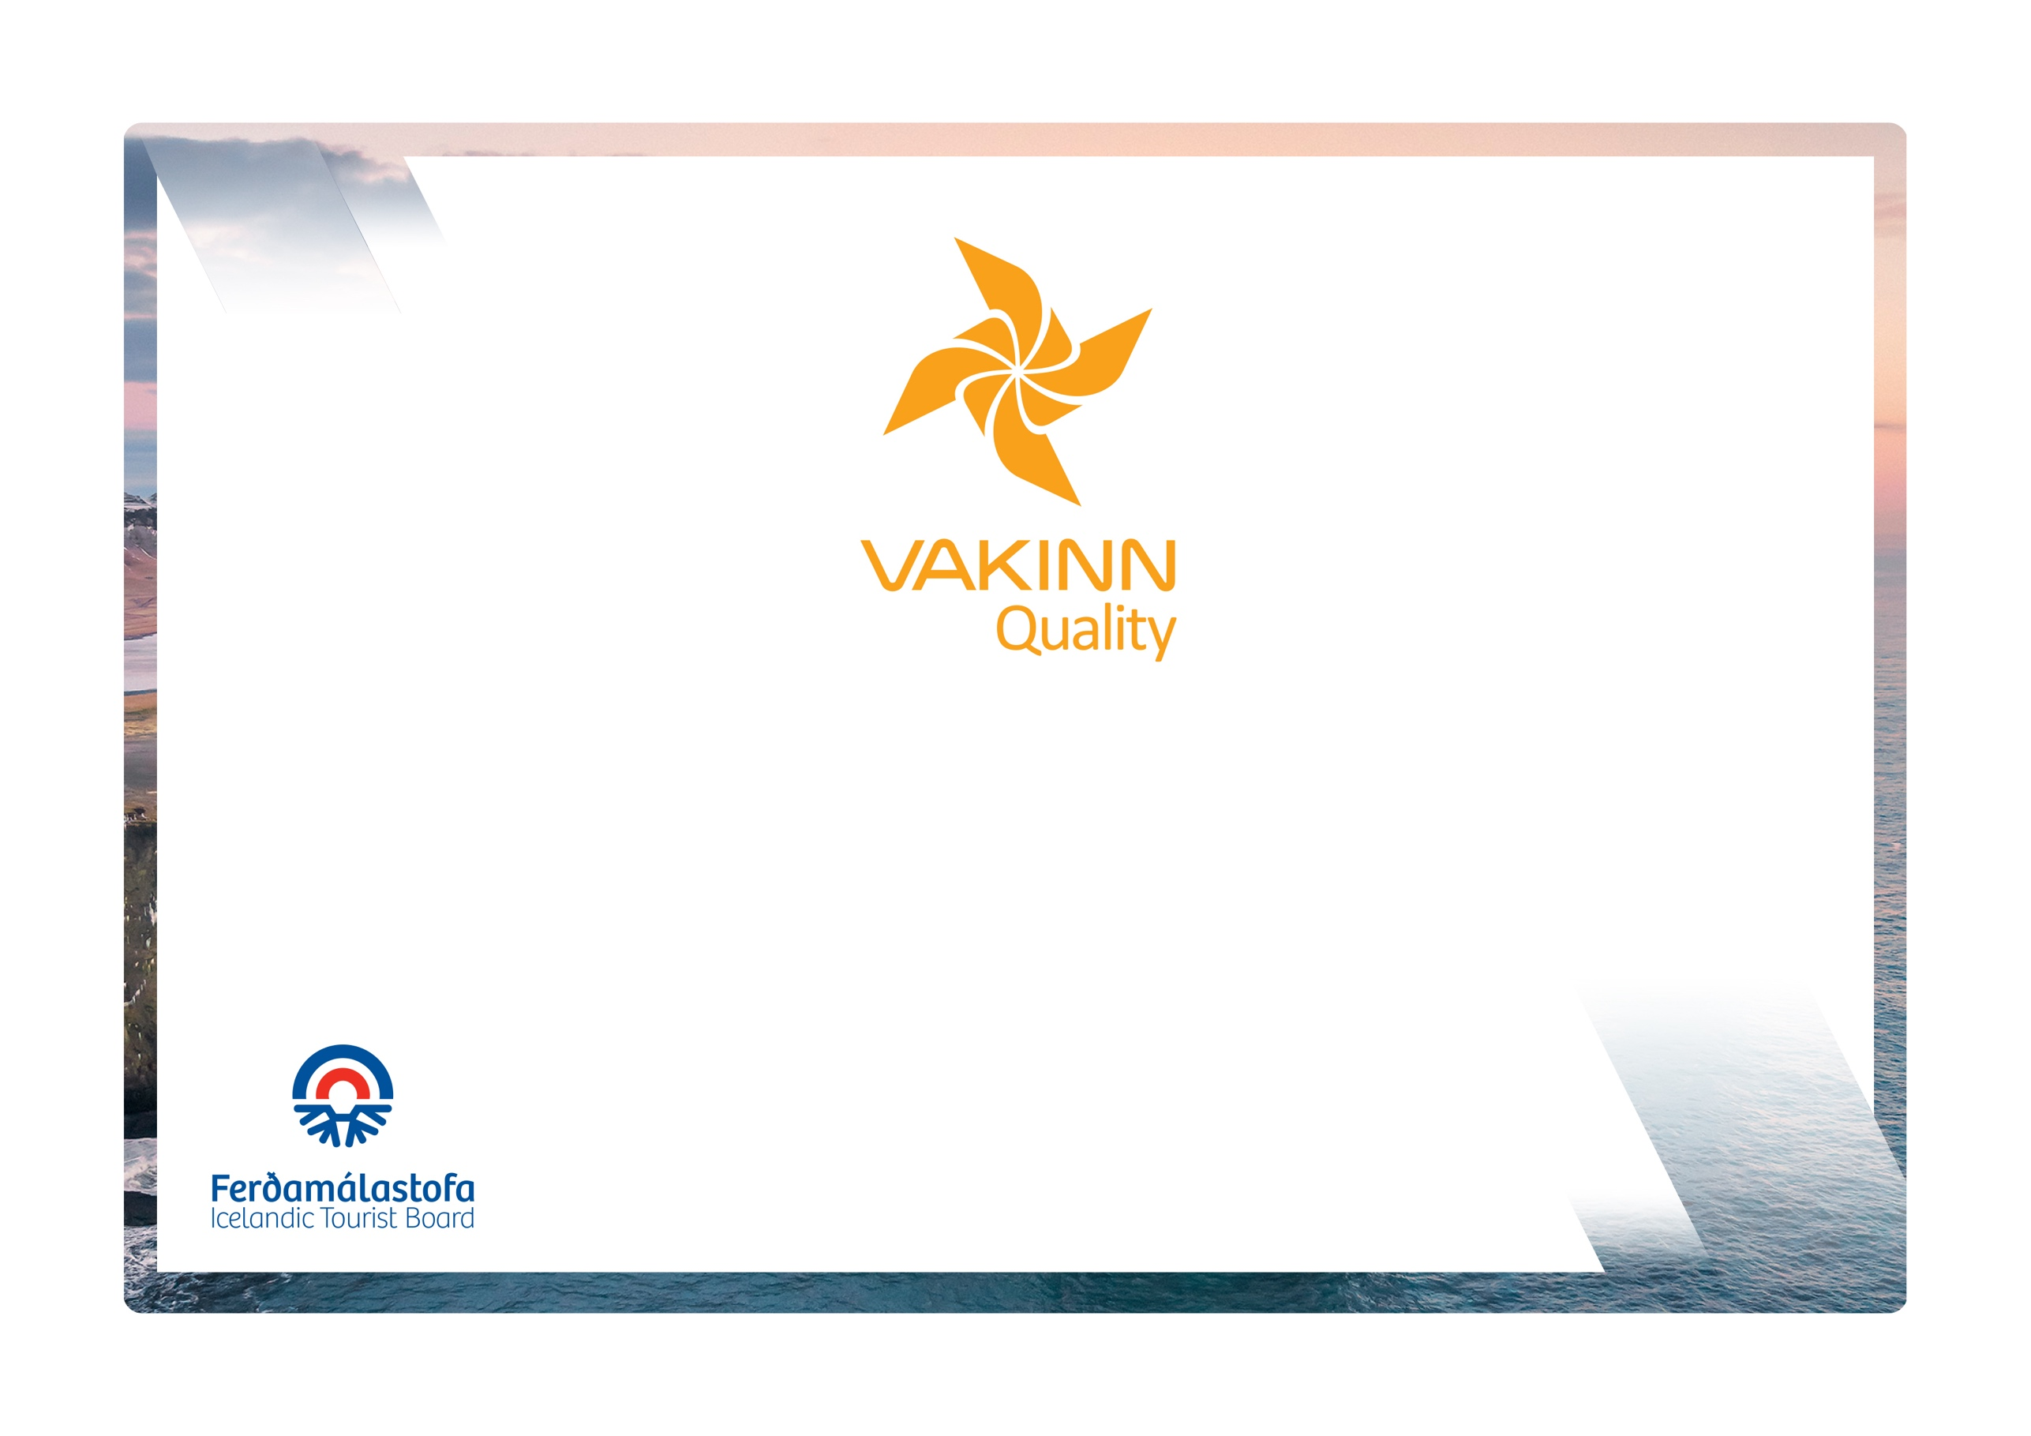

Holiday Homes and Apartments

4th edition 2023
Quality and Environmental Certification
On the Way to Sustainable Tourism

Table of Contents
1. Immediate surroundings 3
1.1 Exterior appearance 3
2. Safety 3
2.1 Lighting, fire protection and more 3
3. Common areas 4
3.1 Facilities and furnishings (living room) 4
3.2 Miscellaneous services 5
3.3 Leisure/recreation 6
4. Guestrooms (sleeping quarters) 6
4.1 Facilities and furniture 6
4.2 Bed and bedlinen 7
5. Kitchen 8
5.1 Facilities and equipment 8
6. Bathroom and toilet facilities 9
7. Hygiene and cleaning 11
7.1 General hygiene 11
7.2 Cleaning appliances (if guests do the cleaning) 11
7.3 Kitchen hygiene 11
8. Education and training of employees 12
9. Accessibility for the disabled 12

The following quality criteria are filled out by a company representative and sent to the auditor along with other documents. A clear explanation of how each applicable criterion is fulfilled must be given with reference to appropriate documentation, e. g. employee handbook/quality manual, safety plans, photos etc. Random and/or selected criteria will be verified by the auditor. Quality criteria marked (N) are new from previous edition.
Criteria marked in red are minimum requirements and must be fulfilled.
Immediate surroundings |  | Yes | No | How fulfilled/explanation

1.1 Exterior appearance
1.1.1 | All signs, markings and flags are in good condition.
1.1.2 | Outdoor lighting is sufficient, e.g. at parking lots, walkways steps, entrances, etc. Careful attention is paid to the maintenance of these areas all year round.
1.1.3 | Inviting outdoor premises e.g. sheltered areas (separated area; a porch or terrace), garden furniture, and flower beds/pots etc.
Safety |  | Yes | No | How fulfilled/explanation

2.1 Lighting, fire protection and more
2.1.1 | Common areas e.g. hallways and stairwells are well lit to ensure the comfort and safety of guests.
2.1.2 | Smoke detectors are in all guestrooms, hallways and other common areas. They are tested regularly.
2.1.3 | Fire extinguishers are on site, tested regulary. Clear instructions for use are visible.
2.1.4 | Fire blanket is in place in the guest kitchen, if applicable.
2.1.5 | Gas detector is in the guest kitchen, if applicable.
2.1.6 | Unhindered access to emergency exits.
2.1.7 | Drawings showing emergency exit routes are prominently displayed in all guestrooms.
2.1.8 | Clear and appropriate information regarding safety, e.g. 112 emergency number for Iceland, safety in and around hot tubs, doctor on call number etc., are displayed in guestrooms or common areas.
2.1.9 | First aid kit is in place, checked and restocked regularly.
2.1.10 | A defibrillator is on site.
2.1.11 | Door viewer is on the front door.
2.1.12 | GPS coordinates of the accommodation is prominently displayed.

Common areas

3.1 Facilities and furnishings (living room)
3.1.1 | Furniture, equipment and fixtures are in a very good condition, little signs of wear and tear.
3.1.2 | Good lighting.
3.1.3 | Window curtains (cloth, blinds, screen or film) where needed.
3.1.4 | Wireless internet access.
3.1.5 | Chairs/seats corresponding to the number of beds (overnight guests).
3.1.6 | Table/side table.
3.1.7 | Accessible electric socket(s).
3.1.8 | Television.
3.1.9 | Couch/comfortable (upholstered) chairs.
3.1.10 | Various light fixtures, e.g. reading lights and lamps.
3.1.11 | Dining room table and chairs.
3.1.12 | Fireplace, clear instructions regarding operation and safety.
3.1.13 | The accommodation is welcoming and provides the atmosphere of a home, e.g. pictures on walls, cushions/pillows on couches, rugs/carpets on floors and other decorative items.

3.2 Miscellaneous services
3.2.1 | Clear information is provided as to where/how to obtain keys, it there is not an on-site receptions.
3.2.2 | Information on how/where to reach employees.
3.2.3 | House rules are clear and prominently displayed e.g. at reception/service building or information folder.
3.2.4 | Clear written instructions for guests as to what is expected of them before vacating the premises, e.g. regarding cleaning of the accommodation, cleaning and safeguarding hot tub, garbage disposal etc.
3.2.5 | Rules regarding pets are clear and displayed to guests on site and on the company website or in other promotional material.
3.2.6 | Clearly identified on-site reception.
3.2.7 | Laundry facilities are in the common area (service building or shared laundry room).
3.2.8 | Washing machine is in the apartment/house.
3.2.9 | Clotheslines/facilities to dry laundry, outdoor or indoors.
3.2.10 | Dryer is in the apartment/house.
3.2.11 | Iron and ironing board is in the apartment/house.
3.2.12 | Outside barbeque/grill in good condition with appropriate instructions.

3.3 Leisure/recreation
3.3.1 | Facilities for leisure activities e.g. table top football, billiard.
3.3.2 | Outdoor play equipment in good condition.
3.3.3 | Books/table top games for the use of guests, tidy and in good condition.
3.3.4 | Hot tub with safe access. Information and guidelines for guests clearly displayed.
3.3.5 | Bicycles can be rented on site.

Guest rooms (sleeping quarters)

4.1 Facilities and furniture
4.1.1 | Furniture, equipment and fixtures are in a very good condition, little signs of wear and tear.
4.1.2 | Sufficient floor space and doors can be fully opened.
4.1.3 | Adjustable heating is in all rooms.
4.1.4 | At least one window is in each room, in case the window cannot be opened good ventilation/air-conditioning is required.
4.1.5 | Curtains to completely darken the room (black out curtains).
4.1.6 | Clothes hooks/clothes shelves.
4.1.7 | Bedside table/shelf.
4.1.8 | Adequate room lighting.
4.1.9 | Reading light is by the bed.
4.1.10 | Clothes rack with hangers/wardrobe.
4.1.11 | Bedside table/shelf is at each bed.
4.1.12 | Individual reading light is next to each bed.
4.1.13 | Al least one full length mirror in the apartment/house.
4.1.14 | Accessible power socket is in all bedrooms.
4.1.15 | TV is in the master bedroom.

4.2 Bed and bedlinen
4.2.1 | All beds/bunk beds are in good condition.
4.2.2 | Bunk beds may not be higher than two levels. Ladder and safety-bar on the top bunk are required.
4.2.3 | Well-kept and clean mattresses in good condition, minimum 13 cm.
4.2.4 | Single beds, minimum size 0,90m x 2,00m and double beds, minimum size 1,40m x 2,00m.
4.2.5 | Hygienic covers are on all mattresses.
4.2.6 | Well-kept and clean duvets and pillows.
4.2.7 | Clean and well-kept bed linens (sheets, pillow- and duvet cases).
4.2.8 | Well-kept and clean mattresses in good condition, minimum 18 cm.
4.2.9 | Single beds, minimum size 0,90m x 2,00m and double beds, minimum size 1,60m x 2,00m.
4.2.10 | Single beds, minimum size of 0,90m x 2,00m and double beds, minimum size of 1,80m x 2,00m.
4.2.11 | Single beds, minimum size of 1,00m x 2,00m and double beds, minimum size of 2,00m x 2,00m.
4.2.12 | Crib is in the apartment/house.
4.2.13 | Duvets and pillows are according to the number of sleeping places.
4.2.14 | It is possible to rent bed linen.
4.2.15 | Made up beds.
4.2.16 | Two pillows per guest.
4.2.17 | Blanket(s)/(throws).

Kitchen

5.1 Facilities and equipment
5.1.1 | Furniture, equipment and fixtures are in a very good condition, little signs of wear and tear.
5.1.2 | Kitchen table and chairs.
5.1.3 | Ventilation, fan or a hinged/flip up window.
5.1.4 | Good lighting.
5.1.5 | Accessible power socket.
5.1.6 | Refrigerator.
5.1.7 | Stove/cooking hob plates, at least two.
5.1.8 | Sink with plug, hot and cold water. Dishwashing brush, dishwashing liquid and drying rack.
5.1.9 | Work tables.
5.1.10 | Waste sorting bins are clearly marked. (N)
5.1.11 | Tableware: Soup bowls and flat plates, knives, forks, spoons, dessert spoons, water goblets, wine glasses, coffee cups/mugs, cake plates. In accordance to the number of beds.
5.1.12 | Kitchen appliances: Coffee maker, water boiler and toaster in good condition.
5.1.13 | Pots and pans corresponding to the number of guests.
5.1.14 | Mop or broom.
5.1.15 | High chair.
5.1.16 | Freezer/freezing compartment.
5.1.17 | Stove/stove top (ceramic, induction, gas).
5.1.18 | Oven with a rack or baking pan.
5.1.19 | Microwave.
5.1.20 | Dishwasher.
5.1.21 | Tableware: Glasses for white and red wine, beer and liquor, variety of accessories (e.g. dessert dishes and serving plates).
5.1.22 | Plastic plates and tumblers.
5.1.23 | Kitchen utensils: Cheese slicer, bread knife, steak knife, paring knife, stirring spoon, spatula, ladle, strainer, tin/bottle opener, cork screw, liquid measure (dl-measure), measuring spoons, bowls, cutting board(s), hot pads.
5.1.24 | Kitchen appliances: Coffee maker, water boiler, mixer, sandwich grill, hand mixer, waffle iron/pancake-pan. Of high quality and in excellent condition.
5.1.25 | Dishtowels and teacloths.

6. Bathroom and toilet facilities
6.1 | Floors, walls and ceilings are in good condition and show little signs of wear and tear.
6.2 | Opaque glass, film or curtains in windows to ensure the privacy of guests.
6.3 | Adequate ventilation, fan or hinged/flip up window.
6.4 | One WC/bathroom.
6.5 | Shower or bathtub.
6.6 | Washbasin.
6.7 | Shower curtain/door.
6.8 | Adequate lighting at the washbasin and in the ceiling.
6.9 | Accessible power socket near the mirror.
6.10 | Wastebasket.
6.11 | Mirror at the washbasin.
6.12 | Shelf for toiletries.
6.13 | Towel rails or towel hooks.
6.14 | Toilet paper in reserve.
6.15 | Soap at the washbasin.
6.16 | Slip prevention in shower/bathtub.
6.17 | Safety handles in or by the shower/bathtub.
6.18 | Body wash or shower gel at the shower/bathtub.
6.19 | Towels can be rented.
6.20 | Two towels per guest, (one hand towel and one bath towel).
6.21 | Washable bath mat (fabric).
6.22 | Heated towel rails/rack.
6.1 | Hairdryer.

7. Hygiene and cleaning

7.1 General hygiene
7.1.1 | Very high standard of cleanliness and hygiene: No dirt/dust found, not even with a fingertip test on picture frames, doorframes and lamps. Bath/shower and toilet fixtures are clean and free from lime scale.
7.1.2 | The accommodation is checked and cleaned according to written procedures prior to each rental.
7.1.3 | Towel change on demand. To protect the environment guests are encouraged to use towels more than once.
7.1.4 | Cleaning services can be hired e.g. at the end of the rental period.

7.2 Cleaning appliances (if guests do the cleaning)
7.2.1 | Bucket, mops, broom, dustpan and dust cloths (cleaning rags).
7.2.2 | Detergents, cleaners and garbage bags.
7.2.3 | Cleaners and detergents kept out of reach of children.
7.2.4 | A closed cupboard for cleaning equipment and materials.
7.2.5 | Vacuum cleaner.

7.3 Kitchen hygiene
7.3.1 | Refrigerator/cooler/freezer clean and free from unpleasant odours.
7.3.2 | Cupboards and drawers are clean and tidy.
7.3.3 | Tables, cooker, microwave, sinks and dishwasher are clean and tidy.

8. Education and training of employees
8.1 | Employees receive training in cleaning and reception of guests.  Written description, on how this is performed and what is covered, is available.
8.2 | Reception employees receive information about the local environment, e.g. history, culture, recreation and events so they can provide reliable information. Written description on how this is performed and what is covered is available. (N)
8.3 | Employees who do not speak Icelandic are encouraged and supported to learn Icelandic. This is addressed in training for new employees. (N)

9. Accessibility for the disabled
9.1 | The company participates in the project Accessible Tourism, run by the Icelandic Tourist Board, and has confirmed that minimum criteria regarding accessibility for the disabled is fulfilled. (N)
9.2 | The company participates in the project Accessible Tourism, run by the Icelandic Tourist Board, and has confirmed that minimum criteria regarding accessibility for the visually impaired and the blind is fulfilled. (N)
9.3 | The company participates in the project Accessible Tourism, run by the Icelandic Tourist Board, and has confirmed that minimum criteria regarding accessibility for the hearing impaired and the deaf is fulfilled. (N)

