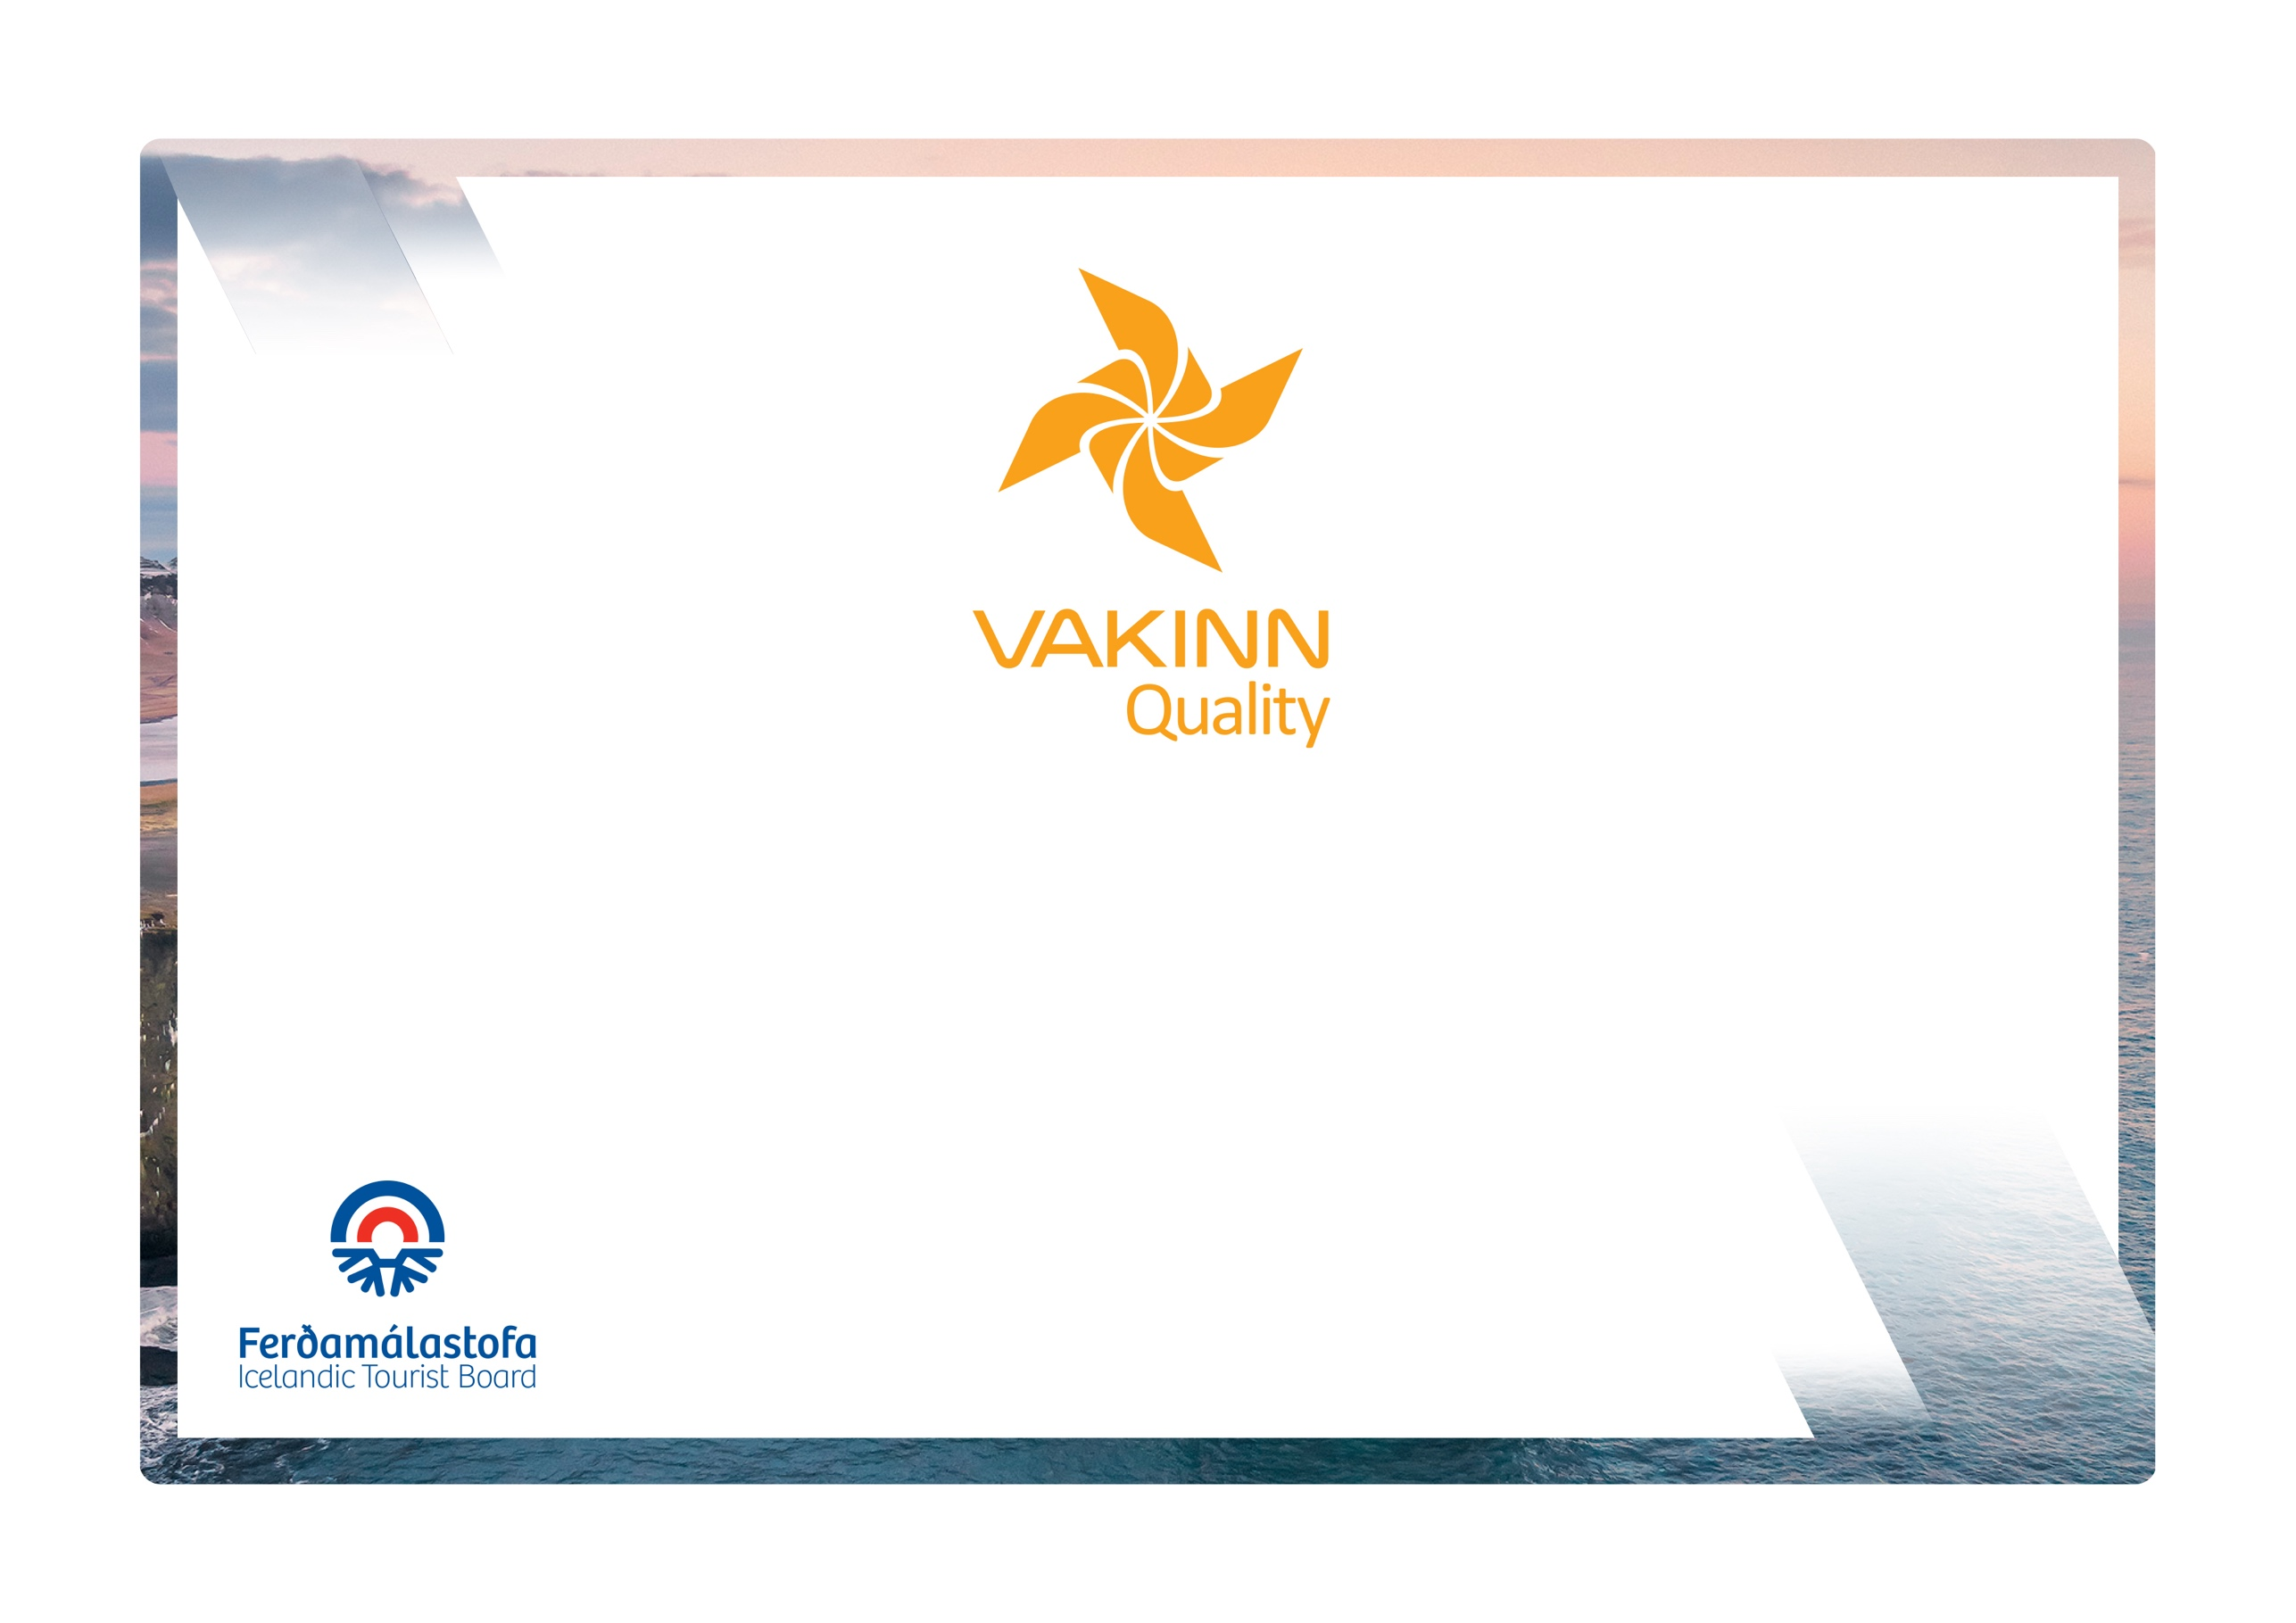
No. 300
5th edition 2022
Environmental Criteria
vakinn.is
Quality and Environmental Certification
On the Way to Sustainable Tourism

BRONS | To obtain a bronze certification, environmental requirements in chapter 4 in the General criteria must be fulfilled.
SILFUR | To obtain a silver certification, environmental requirements in chapter 4 in the General criteria, as well as the silver requirements, must be fulfilled.
GULL | To obtain a gold certification, environmental requirements in chapter 4 in the General criteria, as well as the silver and gold requirements, must be fulfilled.

The following environmental criteria are filled out by a company representative. A clear explanation of how each applicable criterion is fulfilled must be given with reference to appropriate documentation, e. g. employee handbook/quality manual, safety plans, photos etc. Random and/or selected criteria will be verified by the auditor.
300-1 | Silver | How fulfilled/explanation
300-1.1* | The company demonstrates responsibility in the regions it operates in and main destinations e. g. by supporting development, nature conservation, culture and/or community projects in the areas. This is confirmed by written documentation.
300-1.2* | All in all at least 24 actions have been taken (see the checklist On the way to sustainable tourism, and at least four specific actions in each of the following categories:  - Purchasing and resources.  - Energy.  - Waste
300-1.3* | The company has a purchasing policy, which supports sustainability, emphasizing on environmentally friendly purchasing, e. g. the following:  - Products and raw materials produced in Iceland.  - Products and raw materials from the local area.  - Eco-labelled products.  - Organically certified products.  - Fairtrade products, e. g. coffee, tea, cocoa and sugar.  - Avoid buying disposable products.
300-1.4* | The company monitors its environmental performance and keeps  records of regular measurements for the last 12 months at least. The recorded measurements cover at least three of the following categories:  - Fuel consumption.  - Electricity consumption.  - Hot water consumption.  - Waste.
300-1.5 | The company has studied ways and set time bound goals for the following:  - Measure carbon-footprint.  - Reduce emission of greenhouse gases.  - Offset carbon footprint.  See for example www. climatepulse.is
300-2 | Gold | How fulfilled/explanation
300-2.1* | In addition to waste sorting facilities in public areas (i. e. criteria 200-4.7) facilities are also provided in guestrooms, in meeting rooms and aboard vehicles.  Detailed guidelines and information about the company’s waste management are visible to guests/clients.
300-2.2* | All in all at least 50 actions have been taken (see the checklist „On the way to sustainable tourism “), and at least six specific actions in each category:  - Purchasing and resources.  - Energy.  - Waste.
300-2.3* | The company monitors its environmental performance and records regular measurements covering at least 24 months. The responsible party is defined. The records show progress or the maintaining of good performance for at least three of the following categories:  - Fuel consumption.  - Electricity consumption.  - Hot water.  - Waste.
300-2.4* | The company measures its carbon footprint and has set realistic and appropriate goals for its reduction. See f. x. Festa´s climate meter http://climatepulse.is/
300-2.5 | The company has a sustainability policy, visible on the company’s website (valid from January 1st 2023).
300-2.6 | The company informs its employees, customers and partners about its performance in the field of sustainability (e. g. by publishing a sustainability report (valid from January 1st 2023).

Facilities for sorting on each floor of accommodation are allowed. If there are several accommodation blocks (corridors) on each floor, there must be facilities for the category in each accommodation block (corridor). Each room must have clear information and instructions.
Drivers or/and guides may handle the sorting.

