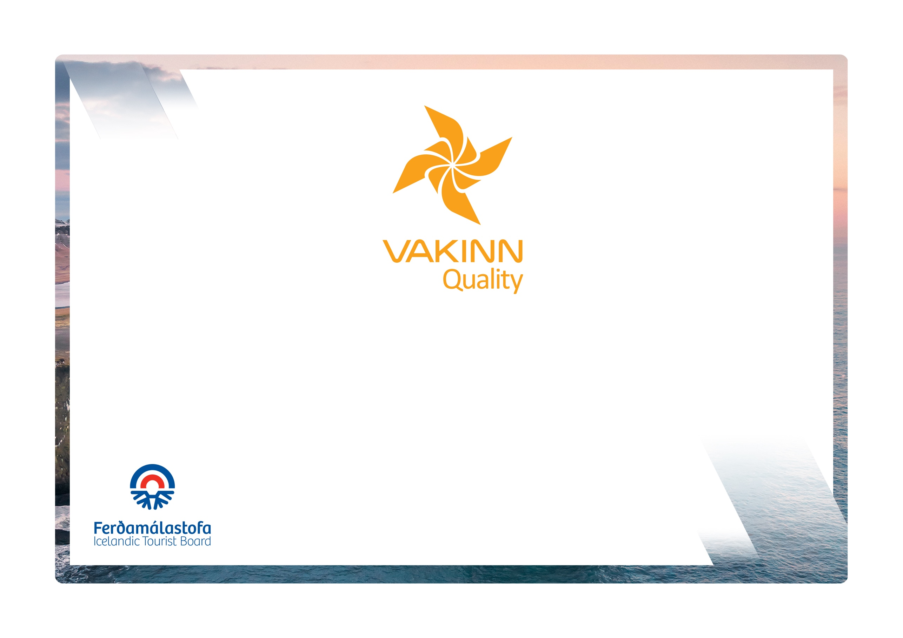

Angling
Quality and Environmental Certification
On the Way to Sustainable Tourism

vakinn.is
Specific Quality Criteria no. 226
5th edition 2022
The following quality criteria are filled out by a company representative. A clear explanation of how each applicable criterion is fulfilled must be given with reference to appropriate documentation, e. g. employee handbook/quality manual, safety plans, photos etc. Random and/or selected criteria will be verified by the auditor.
226-1 | Safety | Yes | N/A | How fulfilled/explanation
226-1.1 | A checklist has been compiled for safety equipment on tours and excursions, including f.ex.:  - First aid kit/equipment.  - Life vests  - Cast lines.  - Communication devices.  - Tracking devices.  - Extra clothing.  - Other equipment according to conditions on each tour.
226-1.2 | A written plan for renewal, cleaning and maintenance of safety  equipment is in place including procedures about i.a.:  - Inspection and testing of equipment.  - Disinfection and cleaning of equipment.  - Lifespan of equipment (see manufacturer's accepted standards).
226-1.3 | To prepare guides for the tours/activities of each day they go through a checklist including the following items, among others:  - Details of the itinerary and routes to be travelled.  - Weather forecast.  - Equipment.  - Information about customers  - That contingency plans are always included / accessible on tours.
226-1.4 | There is a checklist for guides on the safety matters that are covered with customers before and during the tour, e. g. regarding:  - Local conditions and weather.  - Schedule.  - Proper use of safety equipment.  - Appropriate clothing  - Precautions for rivers and lakes.  - 112 emergency number in Iceland.
226-1.5 | Written rules apply to customer/guide ratio according to conditions on each tour.
226-1.6 | The company has written guidelines on when to cancel tours due to weather. It is clearly stated who decides on the cancellation of tours.
226-2 | Environment | Yes | N/A | How fulfilled/explanation
226-2.1 | Marked roads or recognised vehicle tracks are always used. Off-road driving in winter and on glaciers shall be in accordance with Article 4. of Regulation no. 528/2005 regarding restrictions on traffic in Iceland's nature.
226-2.2 | Guides inform their clients about angling rules, e.g. which species it is permitted to catch and the maximum quota.
226-2.3 | All equipment and waste are removed. The company ensures that no permanent traces/damages are seen in the nature in connection with the company‘s tours or activities.
226-2.4 | The company consults with organisations in charge of conservation in the areas, in which the company operates, at least once a year.
226-2.5 | The company consults the guild of fishing right owners in the area regarding its operations.
226-2.6 | The company ensures that all catch is properly recorded in catch books and other catch registration systems.
226-2.7 | Customers are informed about toilet arrangements where conventional facilities are not available.
226-2.8 | Customers are reminded of responsible behaviour i.e. that all off-road driving is illegal.
226-3 | Facilities and Equipment | Yes | N/A | How fulfilled/explanation
226-3.1 | Customers are made aware of the fact that all fishing gear that has been used abroad must be sanitised, according to the requirements of the Icelandic Food and Veterinary Authority, before being brought into the country. Customers are informed about the facilities at Keflavík airport and in Seyðisfjörður for these purposes.
226-3.2 | The company has facilities to process catch, store it and prepare for transport.
226-4 | Education and Training | Yes | N/A | How fulfilled/explanation
226-4.1 | Guides have completed specialized training/education, e.g. are certified guides and/or have substantial experience appropriate for the tour in question.
226-4.2 | Guides on tours through the wilderness* receive training in the use of equipment f. ex. to be able to provide a correct location and information on accessibility to areas visited if assistance is required. In the training the following shall be covered:  - Use of compass and map.  - Use of GPS positioning device.  - Use of appropriate means of communication for different areas, e.g. mobile phone, radio and Tetra.
226-4.3 | Guides have knowledge of the following:  - Species of fish, their way of life and life cycles.  - Current laws on salmon- and trout-fishing and the organisation of fishing control.  - Fishing controls in the appropriate area, including fishing season, bait and size criteria.  - Handling of catch-release fish.  - Appropriate sampling such as scale samples.
226-4.4 | Guides have completed the course Wilderness First Aid (Fyrsta hjálp 1, 20 hours) from ICE-SAR or a comparable course from another organisation and attend a refresher course (4 hours) every two years.
226-4.5 | At least one employee on tours through the wilderness*, e. g. guide, has completed the course Wilderness First Responder (WFR) from ICE-SAR, or a comparable course from another organisation, and attends a refresher course every three years.
226-4.6 | At least one employee on tours through the wilderness* has completed the course Navigation from ICE-SAR or a comparable course from another organisation.
* Wilderness is a place or area where it takes at least two hours to get assistance/rescue from first responders by land.

