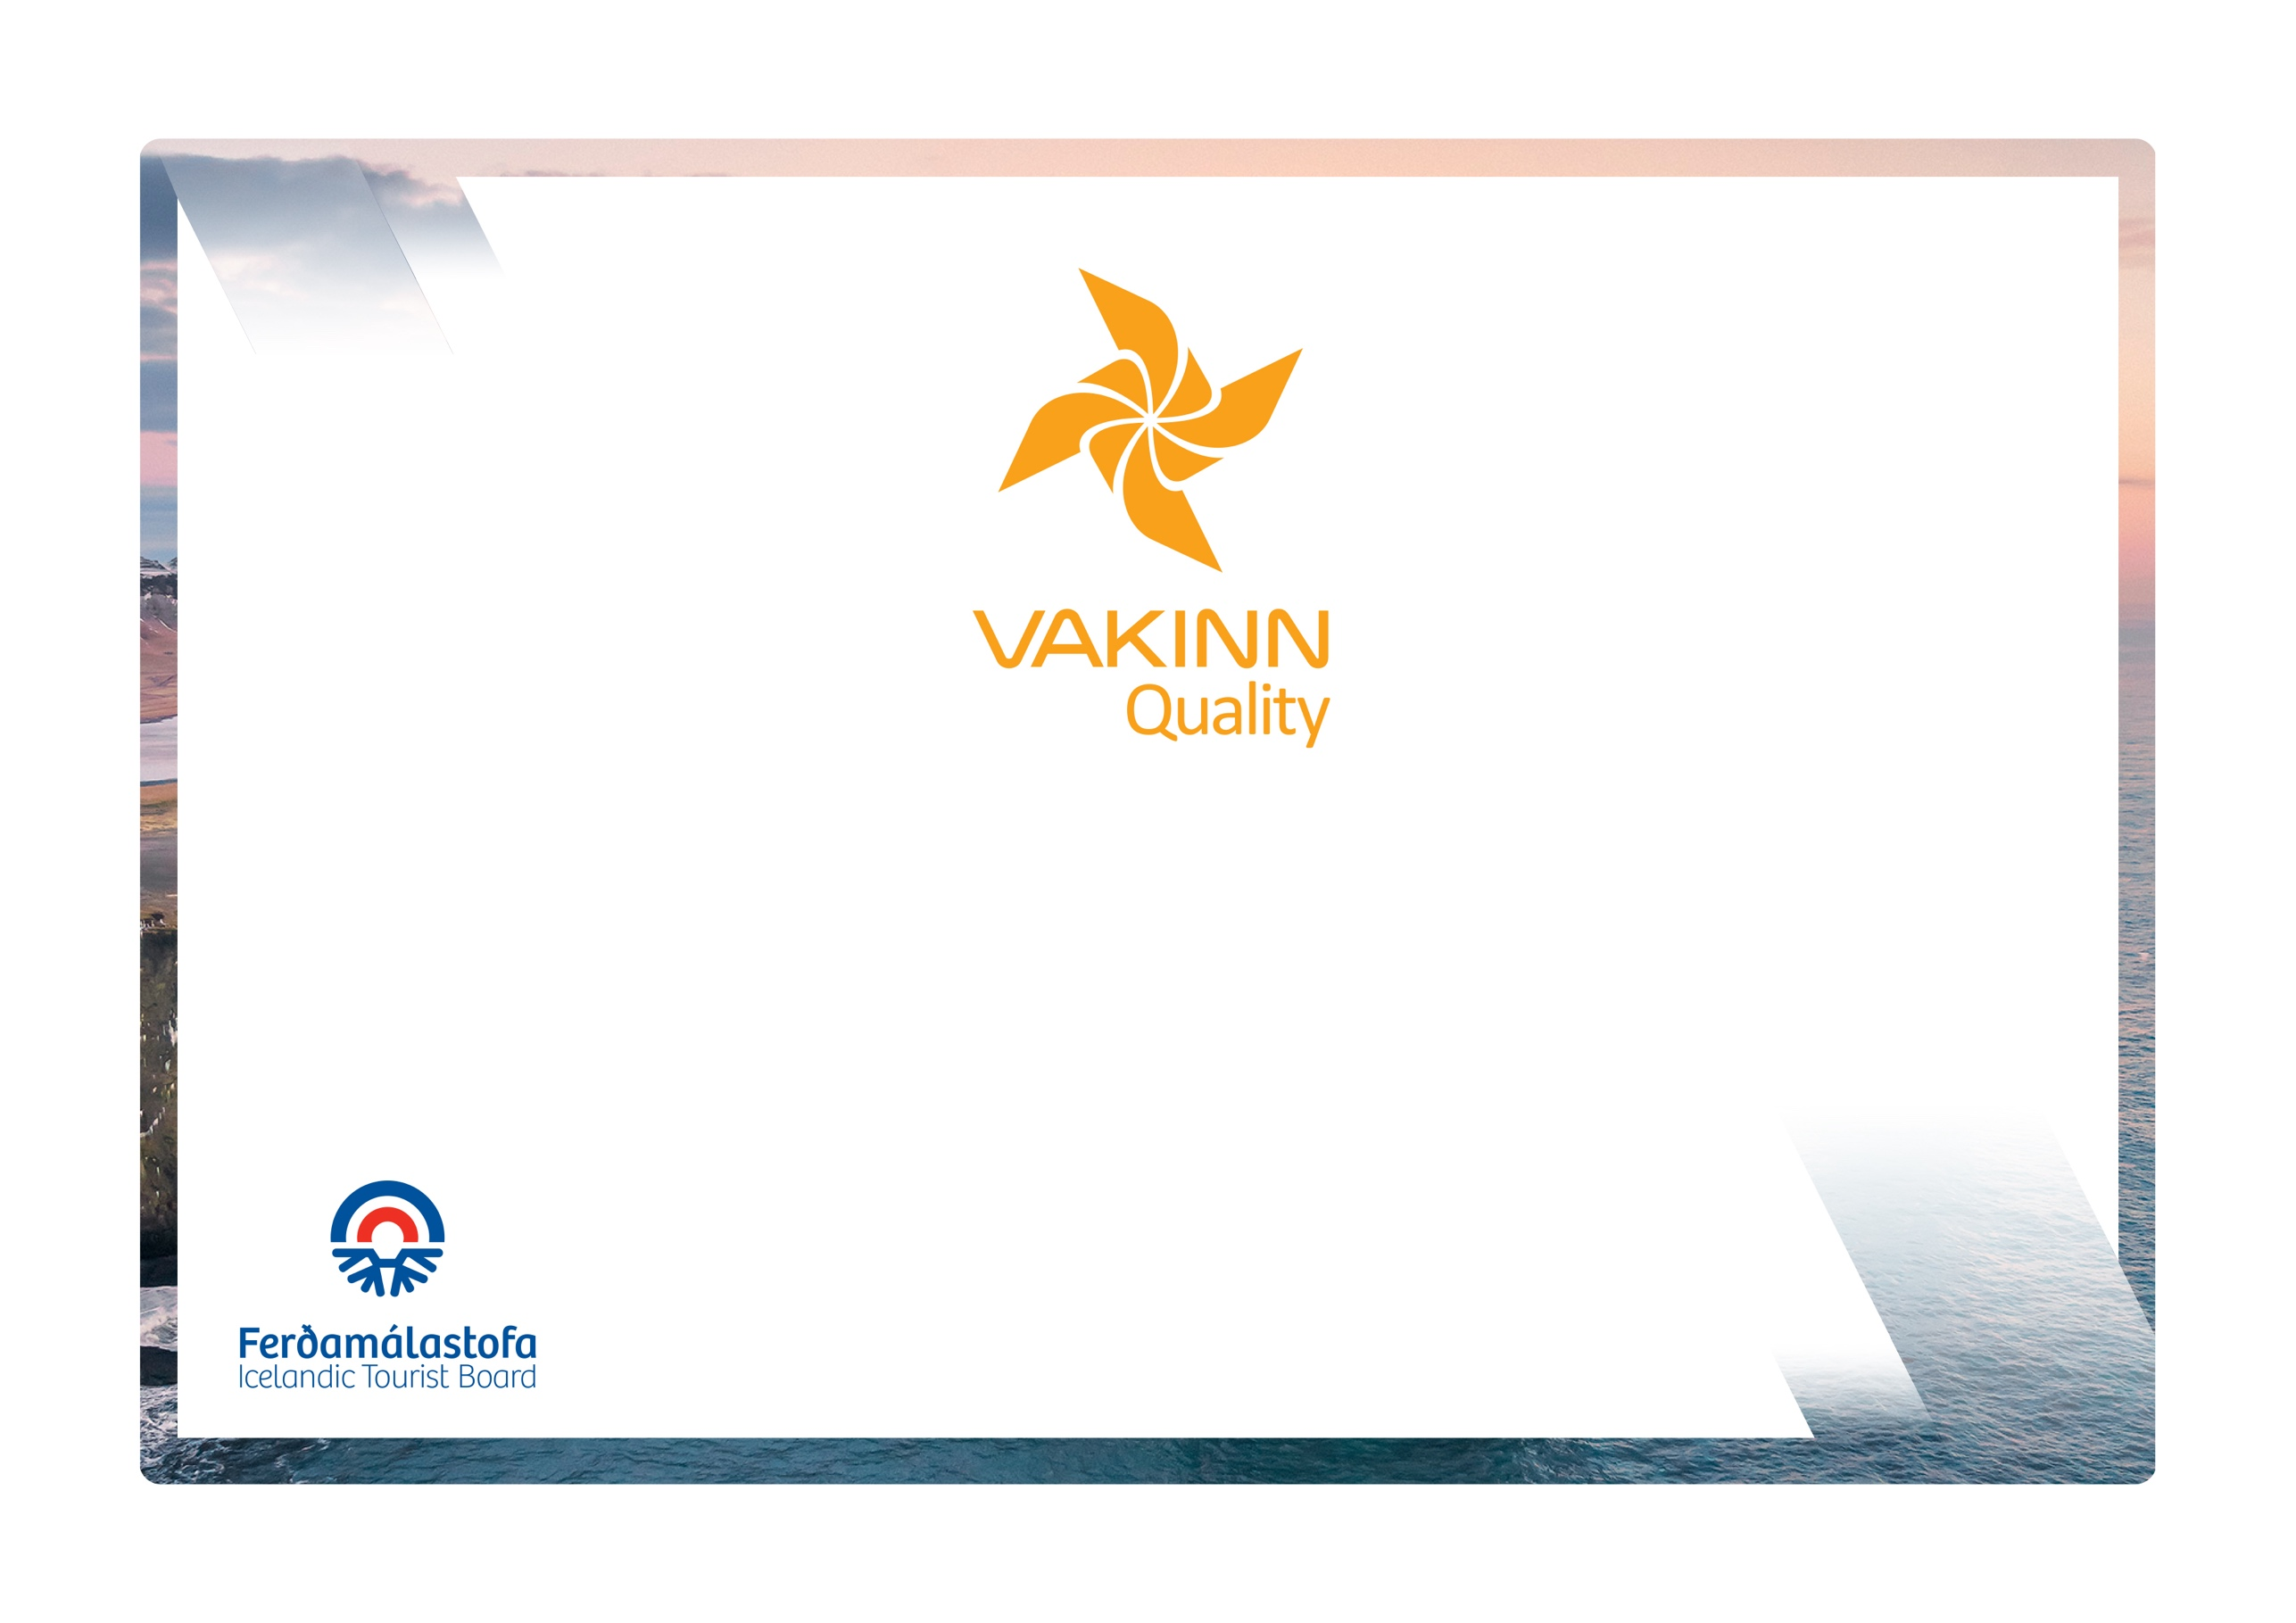
vakinn.is

Coaches

Quality and Environmental Certification
On the Way to Sustainable Tourism

Specific Quality Criteria no. 220
5th edition 2022
The following quality criteria are filled out by a company representative. A clear explanation of how each applicable criterion is fulfilled must be given with reference to appropriate documentation, e. g. employee handbook/quality manual, safety plans, photos etc. Random and/or selected criteria will be verified by the auditor.
220-1 | Safety | Yes | N/A | How fulfilled/explanations
220-1.1 | For each type of tours there is an itinerary (written description) including a description of routes, schedule and other trip arrangements.
220-1.2 | A checklist has been compiled for safety equipment on tours i.a.:  - First aid kit/equipment.  - Communication devices.  - Tracking devices.  - Other equipment according to conditions on each tour.
220-1.3 | In preparation for each tour, and in the beginning of each day in longer tours, the drivers go through a checklist including the following items, among others:  - Details of the itinerary and routes to be travelled.  - Weather forecast.  - Road condition.  - Equipment.  - Information about passengers/customers, if applicable.  - That contingency plans are always included / accessible on tours.
220-1.4 | All drivers can at all times easily contact the shift supervisor/immediate supervisor.
220-1.5 | The company ensures that drivers know where and how to call for assistance if needed, e. g. if a couch needs to be brought to a garage, an assistance from the police or hospital/healthcare is needed, etc. Furthermore, it is ensured that people concerned are notified of a delay or postponement of a trip.
220-1.6 | The work environment of guides is assessed and their safety ensured, e. g.:  - Facility/space for work items and extra clothing.  - Sufficient legroom.  - Hands free microphone.  - Rear view mirrors.
220-1.7 | The company has written guidelines on when to cancel tours due to weather. It is clearly stated who decides on the cancellation of tours.
220-1.8 | The company keeps a register of drivers, detailing drivers licence numbers, endorsement details and expiration date.
220-1-9 | Vehicles are cleaned and disinfected according to written cleaning plans.
220-1.10 | A written plan for maintenance of vehicles is in place detailing i.a. daily checks performed by the driver and weekly/monthly/annually inspections performed by maintenance teams. A maintenance log book is kept.
220-2 | Environment | Yes | N/A | How fulfilled/explanations
220-2.1 | Marked roads or recognised vehicle tracks are always used. Off-road driving in winter and on glaciers shall be in accordance with Article 4. of Regulation no. 528/2005 regarding restrictions on traffic in Iceland's nature.
220-2.2 | Streams and rivers are only crossed in designated places and only where wading is considered safe. Where the riverbank is not maintained in terms of wading, damage to the environment shall be prevented as possible.
220-2.3 | The company uses marked rest stops where possible.
220-2.4 | Customers are informed about toilet arrangements where conventional facilities are not available.
220-2.5 | All equipment and waste is removed. The company ensures that no permanent traces/damages are seen in the nature in connection with the company‘s tours or activities.
220-2.6 | The company has established clear rules on the idling of vehicle engines.
220-2.7 | Customers are reminded of responsible travel behaviour.
220-3 | Education and Training | Yes | N/A | How fulfilled/explanations
220-3.1 | Drivers attend a refresher course in basic first aid (4 hours) every two years.
220-3.2 | Drivers on tours in the highlands have experience of driving in the wilderness such as:  - Driving on mountain trails or challenging difficult routes.  - Crossing of stream water/rivers

