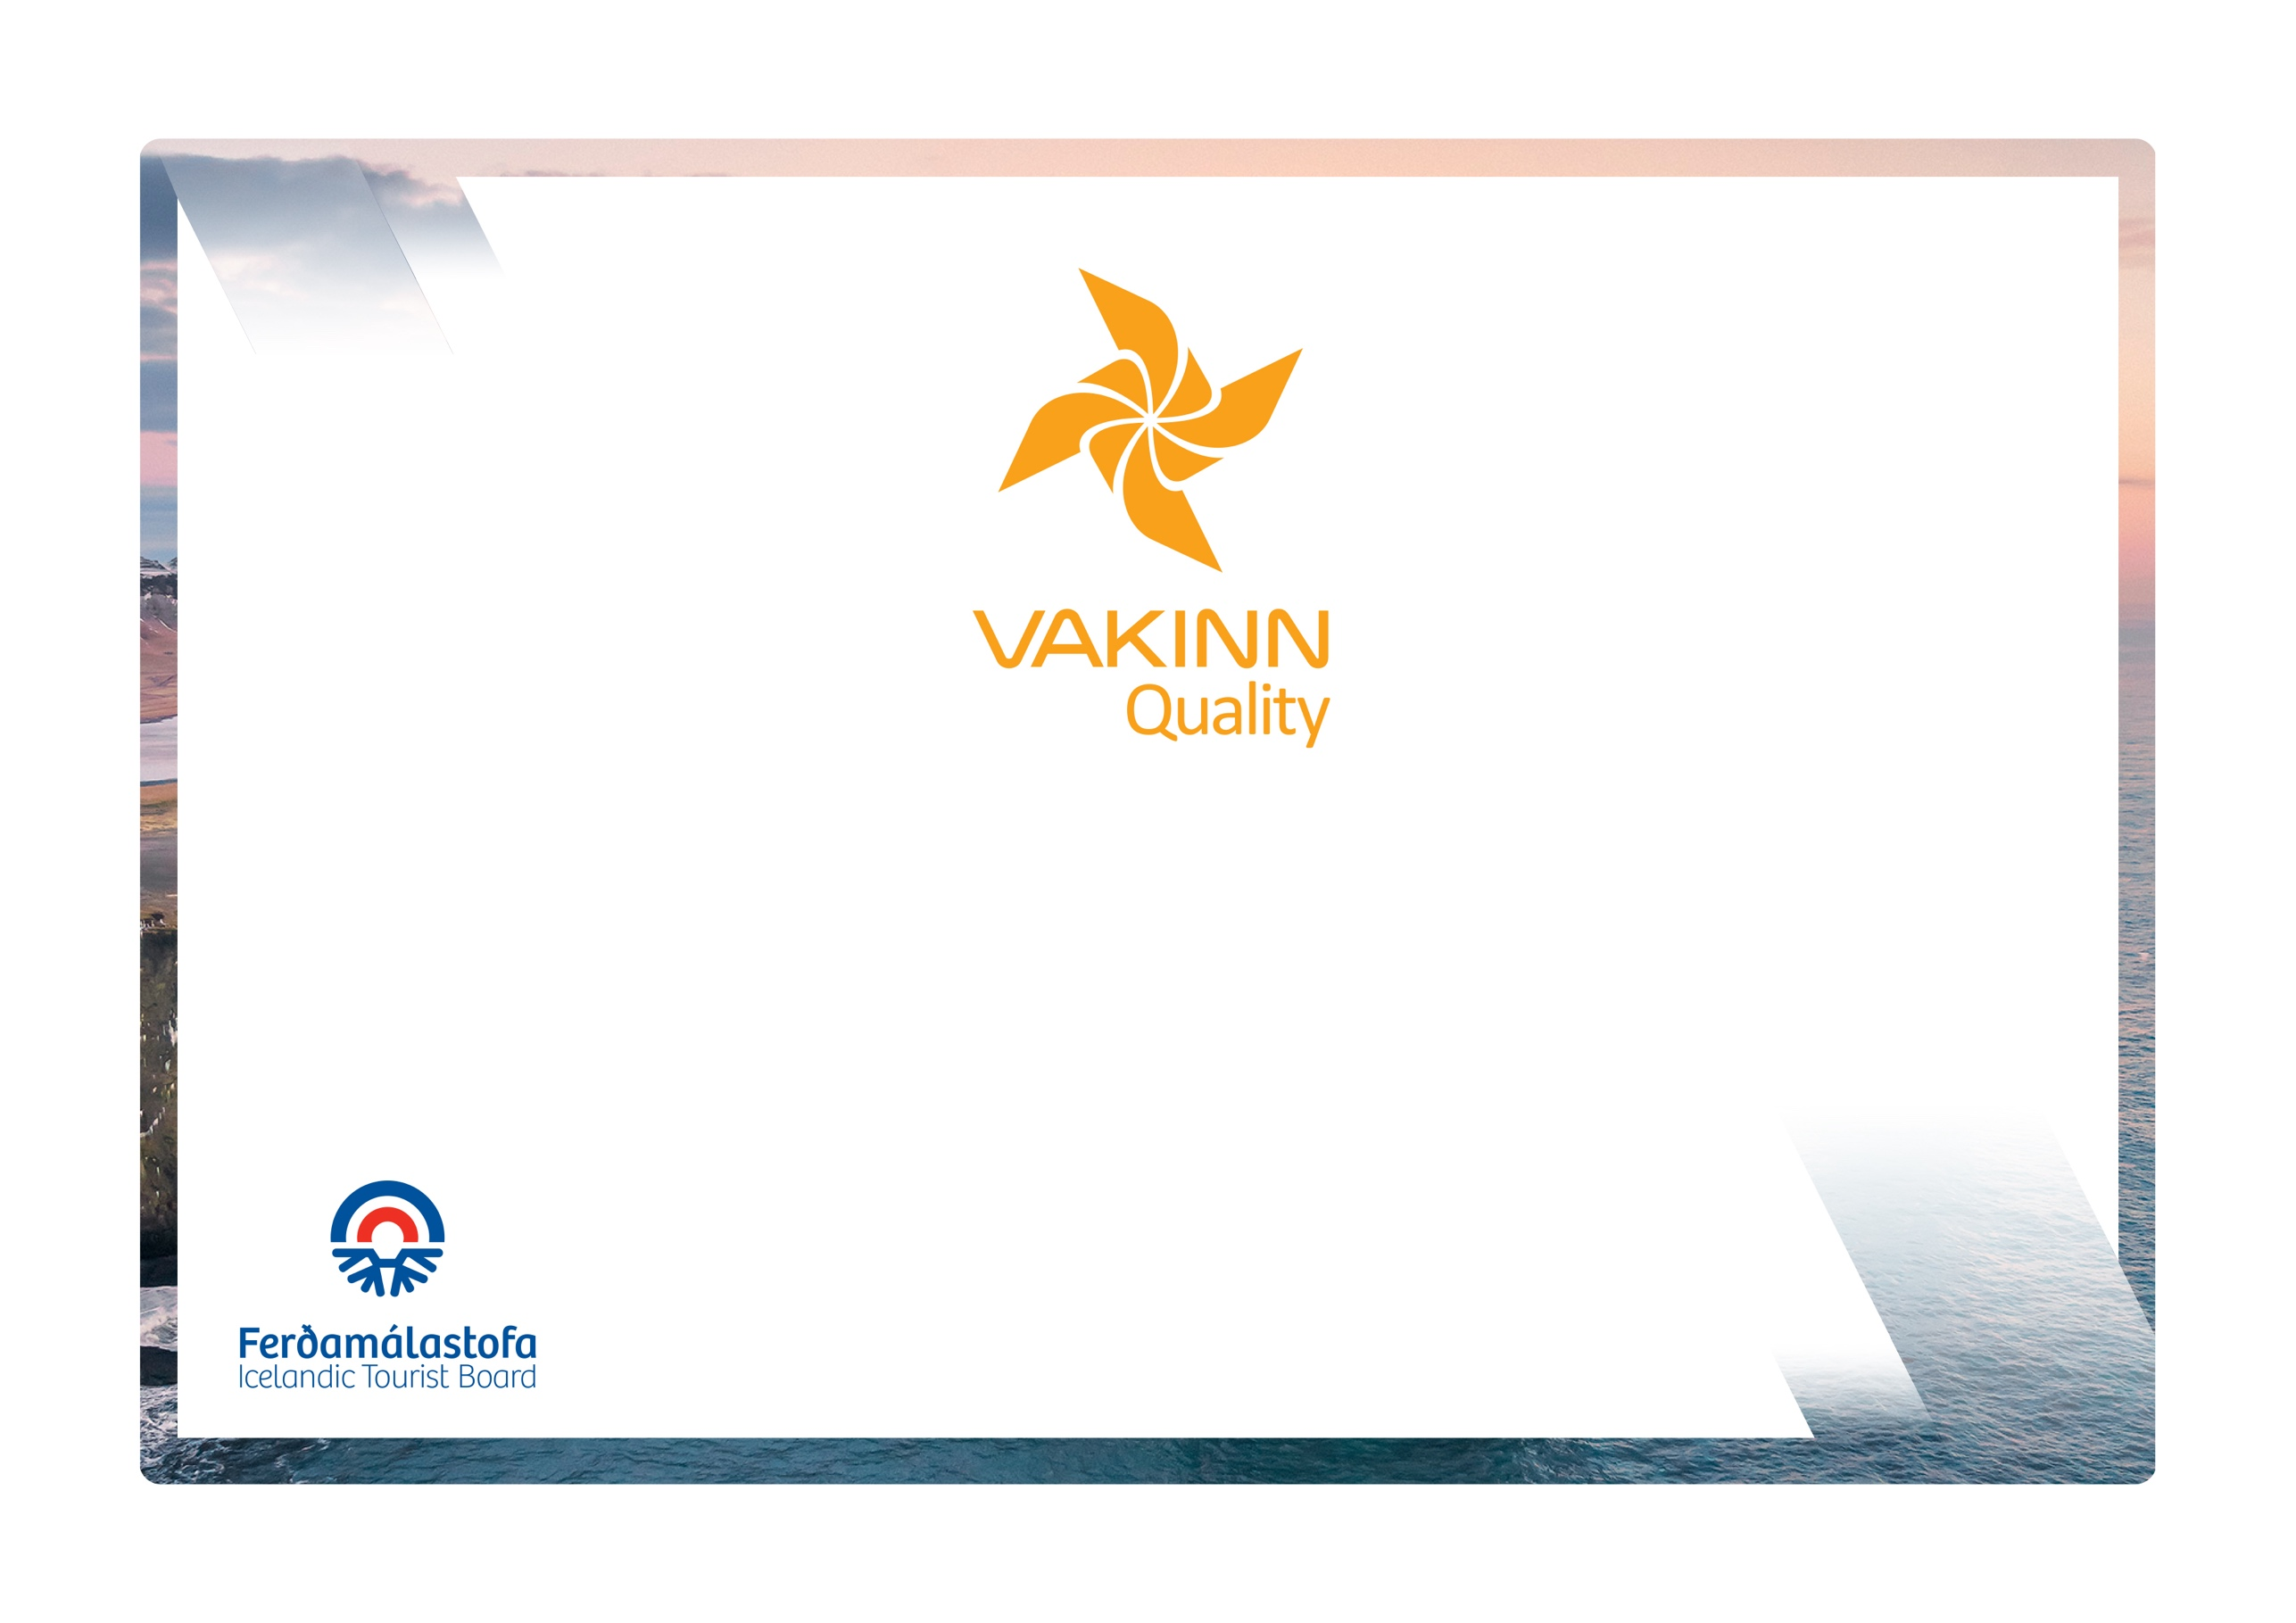

vakinn.is
Quality and Environmental Certification
On the Way to Sustainable Tourism

Specific Quality Criteria no. 217
5th edition 2022
River Rafting
The following quality criteria are filled out by a company representative. A clear explanation of how each applicable criterion is fulfilled must be given with reference to appropriate documentation, e. g. employee handbook/quality manual, safety plans, photos etc. Random and/or selected criteria will be verified by the auditor.
217-1 | Safety | Yes |  | N/A | How fulfilled/explanation
217-1.1 | For each type of tours there is an itinerary (written description) including a description of routes, schedule and other trip arrangements.
217-1.2 | A checklist has been compiled for safety equipment on tours and excursions e.g.:  - First aid kit/equipment.  - Communication devices.  - Tracking devices.  - Rescue equipment (including a safety line).  - Helmets.  - Other equipment according to conditions on each tour.  It is clear what must be in each boat.
217-1.3 | All equipment is in a very good condition, i.e.:  - Helmets and fasteners unbroken and in order.  - Belts and straps unbroken.  - Dry suits and other clothing are clean and in a very good condition.
217-1.4 | All equipment is well and neatly stored after usage. The storage is appropriate and does not reduce the safety and usability of the equipment.
217-1.5 | The company informs employees and customers of the necessity of being in good physical condition and that the use of alcohol or drugs can make them unfit to take part in a tour.
217-1.6 | A written plan for renewal, cleaning and maintenance of safety  equipment is in place including procedures about i.a.:  - Inspection and testing of equipment.  - Disinfection and cleaning of equipment.  - Lifespan of equipment (see manufacturer's accepted standards).
217-1.7 | Written rules apply to customer/guide ratio according to conditions on each tour. On grade 4 rivers or above, the maximum number of clients per guide is 8.
217-1.8 | The minimum age for participation in rafting is specified in the company’s safety plan. A parent/guardian must confirm permission for the participation of minors.
217-1.9 | To prepare guides for the tours/activities of each day they go through a checklist including the following items, among others:  - Details of the itinerary and routes to be travelled.  - Weather forecast.  - Equipment.  - Information about customers.  - That contingency plans are always included / accessible on tours.
217-1.10 | Clients have access to heated facilities for changing into rafting attire.
217-1.11 | There is a checklist for guides on the safety matters that are covered with customers before and during the tour, e. g. regarding:  - Local conditions and weather.  - Schedule.  - Safety briefing.  - Use of safety equipment.  - Appropriate clothing and equipment.  - Food, drinks, and access to water during/after the tour.  - 112 emergency number in Iceland.
217-1.12 | The company has a register of locations, with GPS coordinates, where it is suitable to descend into canyons traversed. A printed map, where the places are marked, is also available.
217-1.13 | The company keeps a list of participants, guides and drivers on each tour.
217-1.14 | The company has written guidelines on when to cancel tours due to weather. It is clearly stated who decides on the cancellation of tours.
217-2 | Environment | Yes | N/A |  | How fulfilled/explanation
217-2.1 | Marked roads or recognised vehicle tracks are always used. Off-road driving in winter and on glaciers shall be in accordance with Article 4. of Regulation no. 528/2005 regarding restrictions on traffic in Iceland's nature.
217-2.2 | Customers are informed about toilet arrangements where conventional facilities are not available.
217-2.3 | All equipment and waste are removed. The company ensures that no permanent traces/damages are seen in the nature in connection with the company’s tours or activities.
217-2.4 | Customers are reminded of responsible behaviour towards the environment.
217-3 | Education and Training | Yes | N/A |  | How fulfilled/explanation
217-3.1 | Guides have completed specialized training/education and have substantial experience appropriate for the tour in question.
217-3.2 | The company has established rules on education and training of guides guiding in tours on rivers of grades 1-4.
217-3.3 | All guides complete practical training on the rivers on which they will be guiding. The training is performed according to a written procedure.
217-3.4 | Guides receive training in the use and handling of the boats and equipment they are responsible for.
217-3.5 | Guides have completed the course Wilderness First Aid (Fyrsta hjálp 1, 20 hours) from ICE-SAR or a comparable course from another organisation and attend a refresher course (4 hours) every two years.
217-3.6 | At least one employee on tours through the wilderness*, e.g. guide, has completed the course Wilderness First Responder (WFR) from ICE-SAR or a comparable course from another organisation and attends a refresher course every three years.
217-3.7 | At least one employee on each tour, e.g. guide, has completed the course Swiftwater Rescue Technician 2 (Holds a valid licence as a Swiftwater Rescue Technician from a certified agency i.e. ICE-SAR or Rescue 3 International).

* Wilderness is a place or area where it takes at least two hours to get assistance/rescue from first responders by land.

