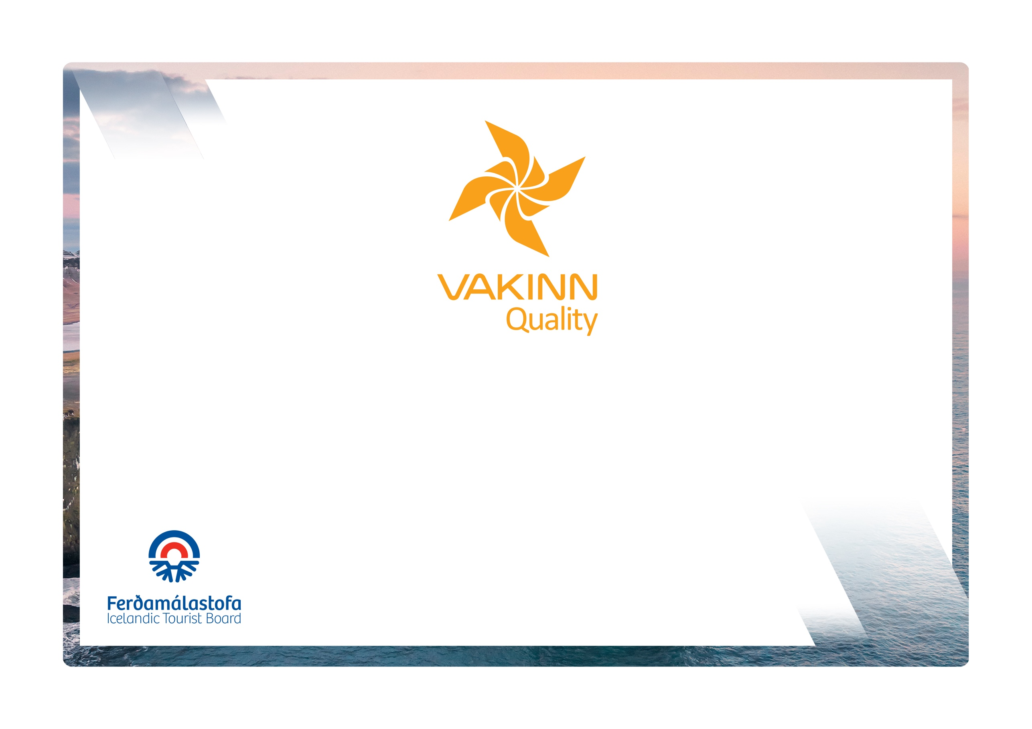
vakinn.is

Hunting

Quality and Environmental Certification
On the Way to Sustainable Tourism

Specific Quality Criteria no. 203
5th edition 2022
The following quality criteria are filled out by a company representative. A clear explanation of how each applicable criterion is fulfilled must be given with reference to appropriate documentation, e. g. employee handbook/quality manual, safety plans, photos etc. Random and/or selected criteria will be verified by the auditor.
214-1 | Safety | Yes | N/A | How fulfilled/explanation
214-1.1 | For each type of tours there is an itinerary (written description) including a description of routes, schedule and other trip arrangements.
214-1.2 | A checklist has been compiled for safety equipment on tours and excursions, including f.ex.:  - First aid kit/equipment.  - Communication devices.  - Tracking devices.  - Extra clothing.  - Whistles.  - Other equipment according to conditions on each tour.
214-1.3 | A written plan for renewal, cleaning and maintenance of safety  equipment is in place including procedures about i.a.:  - Inspection and testing of equipment.  - Disinfection and cleaning of equipment.  - Lifespan of equipment (see manufacturer's accepted standards).
214-1.4 | Written rules apply to customer/guide ratio according to conditions on each tour.
214-1.5 | To prepare guides for the tours/activities of each day they go through a checklist including the following items, among others:  - Details of the itinerary and routes to be travelled.  - Weather forecast.  - Mountain conditions, e.g. avalanche danger.  - Equipment.  - Information about customers.  - That contingency plans are always included / accessible on tours.
214-1.6 | There is a checklist for guides on the safety matters that are covered with customers before and during the tour, e. g. regarding:  - Local conditions and weather.  - Schedule.  - Safety precautions in situations where special care must be exercised.  - Appropriate clothing and equipment.  - Proper use of safety equipment.  - Food, drinks, and access to water during the tour.  - 112 emergency number in Iceland.
214-1.7 | The company has written guidelines on when to cancel tours due to weather. It is clearly stated who decides on the cancellation of tours.
214-2 | Environment | Yes | N/A | How fulfilled/explanation
214-2.1 | The company ensures that all animals and birds are killed in a quick and humane way.
214-2.2 | Guides inform their clients about hunting rules, e.g. which species they are permitted to hunt and maximum hunting quota.
214-2.3 | All equipment and waste are removed. The company ensures that no permanent traces/damages are seen in the nature in connection with the company’s tours or activities.
214-2.4 | Marked roads or recognised vehicle tracks are always used. Off-road driving in winter and on glaciers shall be in accordance with Article 4. of Regulation no. 528/2005 regarding restrictions on traffic in Iceland's nature.
214-2.5 | The company consults with organisations in charge of conservation in the areas, in which the company operates, at least once a year.
214-2.6 | The company consults with landowners when operating on their land, for example on where, when and how often tours take place.
214-2.7 | Customers are informed about toilet arrangements where conventional facilities are not available.
214-2.8 | At the beginning of the tour, the guide reminds the customer of responsible travel behaviour, e. g. that all off-road driving is illegal.
214-3 | Facilities and Equipment | Yes | N/A | How fulfilled/explanation
214-3.1 | The company presents clients with a list of the basic equipment necessary for the intended tour, e.g. suitable clothing and other equipment.
214-3.2 | Appropriate extra equipment for vehicles used in remote areas is at hand in the vehicles, e.g. winches and repair kits.
214-3.3 | The company has facilities to process game, store it and prepare for transport.
214-3.4 | Firearms supplied by clients undergo a test-firing prior to being used in the field.
214-3.5 | All clients must present valid licences and permits relevant to the hunting activity cf. the Current Act on Hunting and Control of Birds and Wild Mammals.
214-3.6 | No facilities/camps are set up without special permission from the relevant stakeholder e.g. landowner, municipality or The Environment Agency of Iceland.
214-4 | Education and Training | Yes | N/A | How fulfilled/Explanation
214-4.1 | Guides hold all required permits and qualifications for the handling of firearms.
214-4.2 | Guides receive training in the use of equipment f. ex. to be able to provide a correct location and information on accessibility to areas visited if assistance is required. In the training the following shall be covered:  - Use of compass and map.  - Use of GPS positioning device.  - Use of appropriate means of communication for different areas, e. g. mobile phone, radio and Tetra.
214-4.3 | Guides have completed the course Wilderness First Aid (Fyrsta hjálp 1, 20 hours) from ICE-SAR or a comparable First Aid course from another organization and attend a refresher course (4 hours) every two years.
214-4.4 | At least one guide on tours through the wilderness* has completed the course Wilderness First Responder (WFR) from ICE-SAR or a comparable course from another organization and attends a refresher course every three years.
214-4.5 | At least one guide on tours through the wilderness* has completed the course Navigation from ICE-SAR or comparable course from another Organization.
214-4.6 | At least one guide on tours through the wilderness* has completed the course Mountaineering from ICE-SAR or a comparable course from another Organization.
* Wilderness is a place or area where it takes at least two hours to get assistance/rescue from first responders by land.

