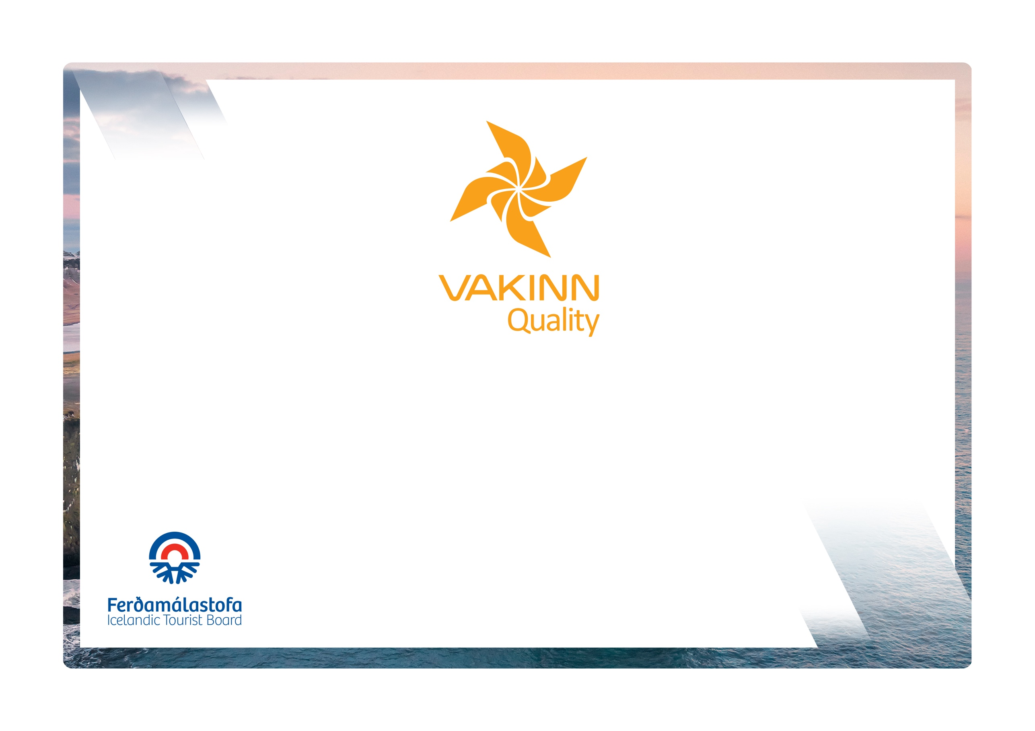
Spas and Wellness
vakinn.is

Quality and Environmental Certification
On the Way to Sustainable Tourism

Specific Quality Criteria no. 212
5th edition 2022
The following quality criteria are filled out by a company representative. A clear explanation of how each applicable criterion is fulfilled must be given with reference to appropriate documentation, e. g. employee handbook/quality manual, safety plans, photos etc. Random and/or selected criteria will be verified by the auditor.
212-1 | Information and Service | Yes | N/A | How fulfilled/explanation
212-1.1 | Following information are visible to customers:  - Services and treatments on offer.  - Temperature and the chemical content of natural substances to which guests have access (bathwater, steam, clay, etc.)  - Advice for those who are particularly sensitive, e.g. to high temperatures.  - Instructions for possible risk of intolerance or other allergic reaction to any of the materials used, is clearly stated.
212-1.2 | Information is available on the origin of the natural products used, e.g. boreholes and their depth, clay-mines etc. The recycling and cleaning/refining of the materials is explained.
212-1.3 | Reception staff has detailed knowledge of the services provided and can convey this information to guests.
212-1.4 | Written instructions for staff, detailing what is included in services/treatments on offer, are in place.
212-2 | Facilities and Hygiene | Yes | N/A | How fulfilled/explanation
212-2.1 | Employees are presentable and dress in clean and appropriate working attire.
212-2.2 | Buildings and facilities have been checked regarding accessibility for all (i. e. for all age groups, persons with restricted mobility, visual or hearing impaired etc.).
212-2.3 | All facilities i.e. reception area, dressing rooms, treatment areas are well designed and tidy. All furniture and fixtures are clean and in an impeccable condition.
212-2.4 | Dressing rooms are spacious with seats and well ventilated. The following amenities are in place:  - Large mirrors.  - Dressing table/shelves.  - Sufficient number of high-quality hair dryers.  - Lockable lockers of good size and with hangers.
212-2.5 | Shower and bathing facilities are well separated from the dressing area to minimise the risk of water getting into dressing rooms.
212-2.6 | Relevant and clear pictorial instructions on how customers are to wash themselves before entering pools, sauna etc. are in the shower and bathing area.
212-2.7 | Treatment rooms are well ventilated and demarcated.
212-2.8 | Treatment rooms are big enough to allow those administering therapy to move easily around the room.
212-2.9 | Propriety and privacy are observed during the entire course of treatment.
212-2.10 | Customers have the opportunity to relax after therapy, in either the treatment space or an appropriate area.
212-2.11 | Bathrobes and slippers are of high quality, clean and in good condition.
212-2.12 | Towels are of good quality, clean and in good condition.
212-2.13 | Written procedures apply to:  - Washing of linens.  - Replacing of linens.  - Cleaning and disinfection of equipment.
212-2.14 | The highest standards of hygiene are always observed. No surface shows signs of grime and grouting is free of mould, no stains or signs of wear and tear of furniture are present.
212-4 | Education and Training | Yes | N/A | How fulfilled/explanation
212-4.1 | Employees administering client treatment must have completed appropriate education and training e.g. beauticians and masseur/masseuse.
212-4.2 | All employees have completed basic first aid course (4 hours) from a certified trainer and attend a refresher course every two years. Applicable for employees and contractors alike.
212-4.3 | Guards in swimming and bathing areas must hold a valid licence and pass an aptitude test annually according to annex no. III in Regulation no. 814/2010 on hygiene in swimming and bathing areas.

