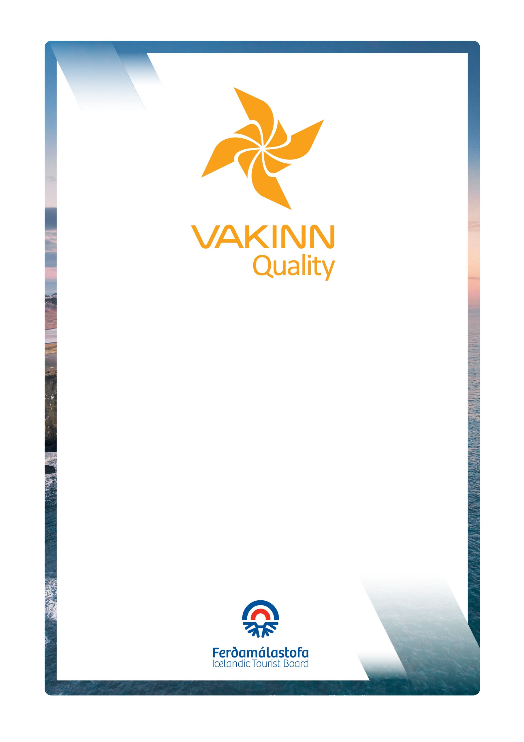
Quality and Environmental Certification
On the Way to Sustainable Tourism

vakinn.is

Tourism Services other than Accommodation
no. 200
5. útgáfa 2022
General Quality Criteria
Gönguferðir í dreifbýli, óbyggðum
og í fjalllendi við sumaraðstæður

Sértæk gæðaviðmið nr. 200
5. útgáfa 2022
VAKINN – Gæða- og umhverfisvottun ferðaþjónustunnar
Á leið til sjálfbærrar ferðaþjónustu

vakinn.is

Following criteria, if applicable, must be fulfilled. Documents and/or photos are required as a confirmation on how the criteria is fulfilled.
1. Website and Information
200-1.1 | The company has a website and / or page on social media with credible images and detailed information that is updated regularly.
200-1.2 | Photos and information on the company´s website and in other promotional material show responsible behaviour towards nature. The company encourages customers to travel responsibly.
200-1.3 | The Vakinn logo and a text about the certification is prominent on company’s website and in other promotional materials (applicable for Vakinn-certified companies).
200-1.4 | It is clearly stated on the company´s website and in other promotional material:  - If the service (or parts of it) is performed by a partner.  - What is included in the price.  - Terms and conditions concerning confirmation fee, cancellations of a trip or order, customer´s absence (now show) and/or refund.
200-1.5 | When booking tours / recreation, customers receive detailed information, e. g. about the following:  - Appropriate protective clothing and equipment.  - Difficulty level of tour / recreation.  - Age limit (if applicable).  - Duration / schedule of tour / recreation.
2. Management and Human Resources
200-2.1* | Specific quality criteria, applicable to the operation, have been filled in. F. ex. horse riding tours, hiking, travel agencies, car rentals etc.
200-2.2* | An employee- and/or quality manual has been compiled covering f. ex.:  - The company´s strategy.  - Vakinn´s quality and environmental certification (applies after the company has received certification).  - Vakinn´s Code of Conduct.  - Safety plans.  - Environmental- or sustainability policy.  - The company's emphasis and rules regarding the natural environment and responsible travel behaviour.  - Occupational safety.  - Service, communication and procedures.  - How to answer inquiries.  - How to receive and handle complaints.  - Cleaning plans and infection prevention.  - Rules on uniforms/attire, cleanliness and personal hygiene.
200-2.3* | The company complies with applicable laws. All relevant licences and permits are valid and visible for guests as appropriate. If the company has a licence from the Icelandic Tourist Board, the licence logo is visible on the company´s website and on other promotional material.
200-2.4* | The operation is run in accordance with the current Act on accounting procedures and pertaining regulations. The customer gets a receipt for purchased services, indicating, among other things, VAT and the seller´s name, identity number and VAT number.
200-2.5* | Liability insurance from an insurance company is valid.
200-2.6* | Written employment contracts/subcontracting agreements are drawn up for all employees and contractors.
200-2.7* | Job descriptions, defining employees’ roles and responsibilities, are available for all positions.
200-2.8* | Written procedures for training and orientation of new employees are in place.
200-2.9* | All frontline employees carry nametags (or are otherwise identifiable) with their own name and/or the company name (uniform e. g. a light jacket, sweater or T-shirt).
200-2.10* | The company maintains a list of staff / guides / contractors who work for or on behalf of the company with information that they have completed courses and received training in accordance with the requirements set out in specific quality criteria that apply to the company's operations (cf. 200-2.1). The list is updated regularly (at least annually).
200-2.11* | There are written procedures for receiving, handling and preservation of complaints and feedback that staff (including guides) are familiar with.
200-2.12* | A manager (and/or an employee with managers support) is responsible for the company´s quality- and safety system according to Vakinn´s criteria. The knowledge of other key employees is guaranteed.
3. Safety and Hygiene
200-3.1* | Safety plans for all services offered by the company have been compiled in Icelandic and English according to Article 11 of Act no. 96/2018 on the Icelandic Tourist Board. Responsible party is defined.  The safety plans are reviewed once a year and more often if needed, especially in the wake of accidents or other mishaps. Safety plans include the following:  - Risk assessment – a precise analysis of risks in the environment where a service is performed or goods are sold, that may potentially lead to accidents.  - Written work procedures – description of work procedures that should be followed to minimise risk of accidents.  - Contingency plan – how to respond in the case of accidents and/or mishaps.  - Incident report – registration of all irregularities, mishaps and/or accidents.
200-3.2* | The company's safety plans are reviewed with staff / guides / contractors each year. There is a written procedure for how this is done.
200-3.3* | Guides / drivers confirm in the employment / contractor agreement that they have studied and work according to the company's safety plans.
200-3.4* | In the case where a partner performs a service in the company’s name, the company gets a confirmation that safety plans from the partner in question have been compiled. This is done according to written procedures.
200-3.5 | At least one employee on each tour (or each shift if applicable) has completed basic first aid course (4 hours) from a certified trainer and attends a refresher course every two years. Applicable for employees and contractors alike (Please note that additional first aid course requirements are in place in various specific quality criteria).
200-3.6 | First aid kit is inspected at least twice a year and as needed. Employee who is responsible is defined.
200-3.7* | Fire preventions are checked at least once a year and employees are given guidance and/or trained in reaction to fire. This is done according to written procedures. Responsible party is defined.
200-3.8 | Facilities indoor and outdoor are clean and well maintained.
200-3.9* | There are written cleaning plans that cover all spaces and areas indoors and outdoors. These include the following:  - Daily cleaning and long-term cleaning.  - Cleaning and disinfection of contact surfaces (during the day and between customers).  - Location and filling of hand sanitizers.
200-3.10* | Where refreshments are available, there are written procedures e.g., about the following:  - How to serve refreshments with regard to hygiene and infection control.  - How customers are instructed on hygiene and infection control.  - How to store refreshments during a trip / service.
- Environment
200-4.1 | A specific individual or group within the company is responsible for the company's environmental matters and sustainability priorities, e. g. regarding the following:  - Information, education and motivation for employees.  - Information and encouragement to partners and suppliers.  - Information for customers.  - Implementation and revision of the action plan.
200-4.2* | The checklist On the Way to Sustainable Tourism has been completed. The checklist is reviewed annually and the company's performance in the field of sustainability is re-evaluated.
200-4.3* | An action plan regarding sustainable tourism has been compiled based on the checklist On the Way to Sustainable Tourism.  - Actions are a minimum of four.  - All actions listed are clarified, timed and responsibility for their execution allocated to a specific employee.  - The action plan is reviewed at least annually and employees kept  informed.
200-4.4 | The company's environmental policy and/or sustainability policy is clearly visible on its website. It includes goals and actions i.a.:  - The company's emphases and rules regarding taking care of the environment and the nature and how the company seeks to reduce negative environmental impacts.  - The company's goals and priorities for climate change.  - The company's goals and emphases for sustainability and social responsibility.
200-4.5 | Employees are familiar with the company's environmental policy / sustainability policy and receive regular information on priorities in this area.
200-4.6* | The company sorts and returns waste for recycling in at least following categories:  - Recyclable bottles and cans.  - Paper, cardboard and plastic.  - Organic waste.  - General waste.  In addition, the company employees sort the following as possible:  - Batteries and hazardous waste.  - Metals.  - Glass.  Detailed work procedures apply to all sorting and handling of waste.
200-4.7 | Guests and employees have access to waste sorting facilities in public areas.  Detailed guidelines and information on the company’s waste sorting are visible to  guests/clients by the waste sorting facilities. Guests are offered the possibility of handing  other waste over to employees for further sorting.
200-4.8 | The company has studied ways to measure the carbon footprint resulting from its operations.
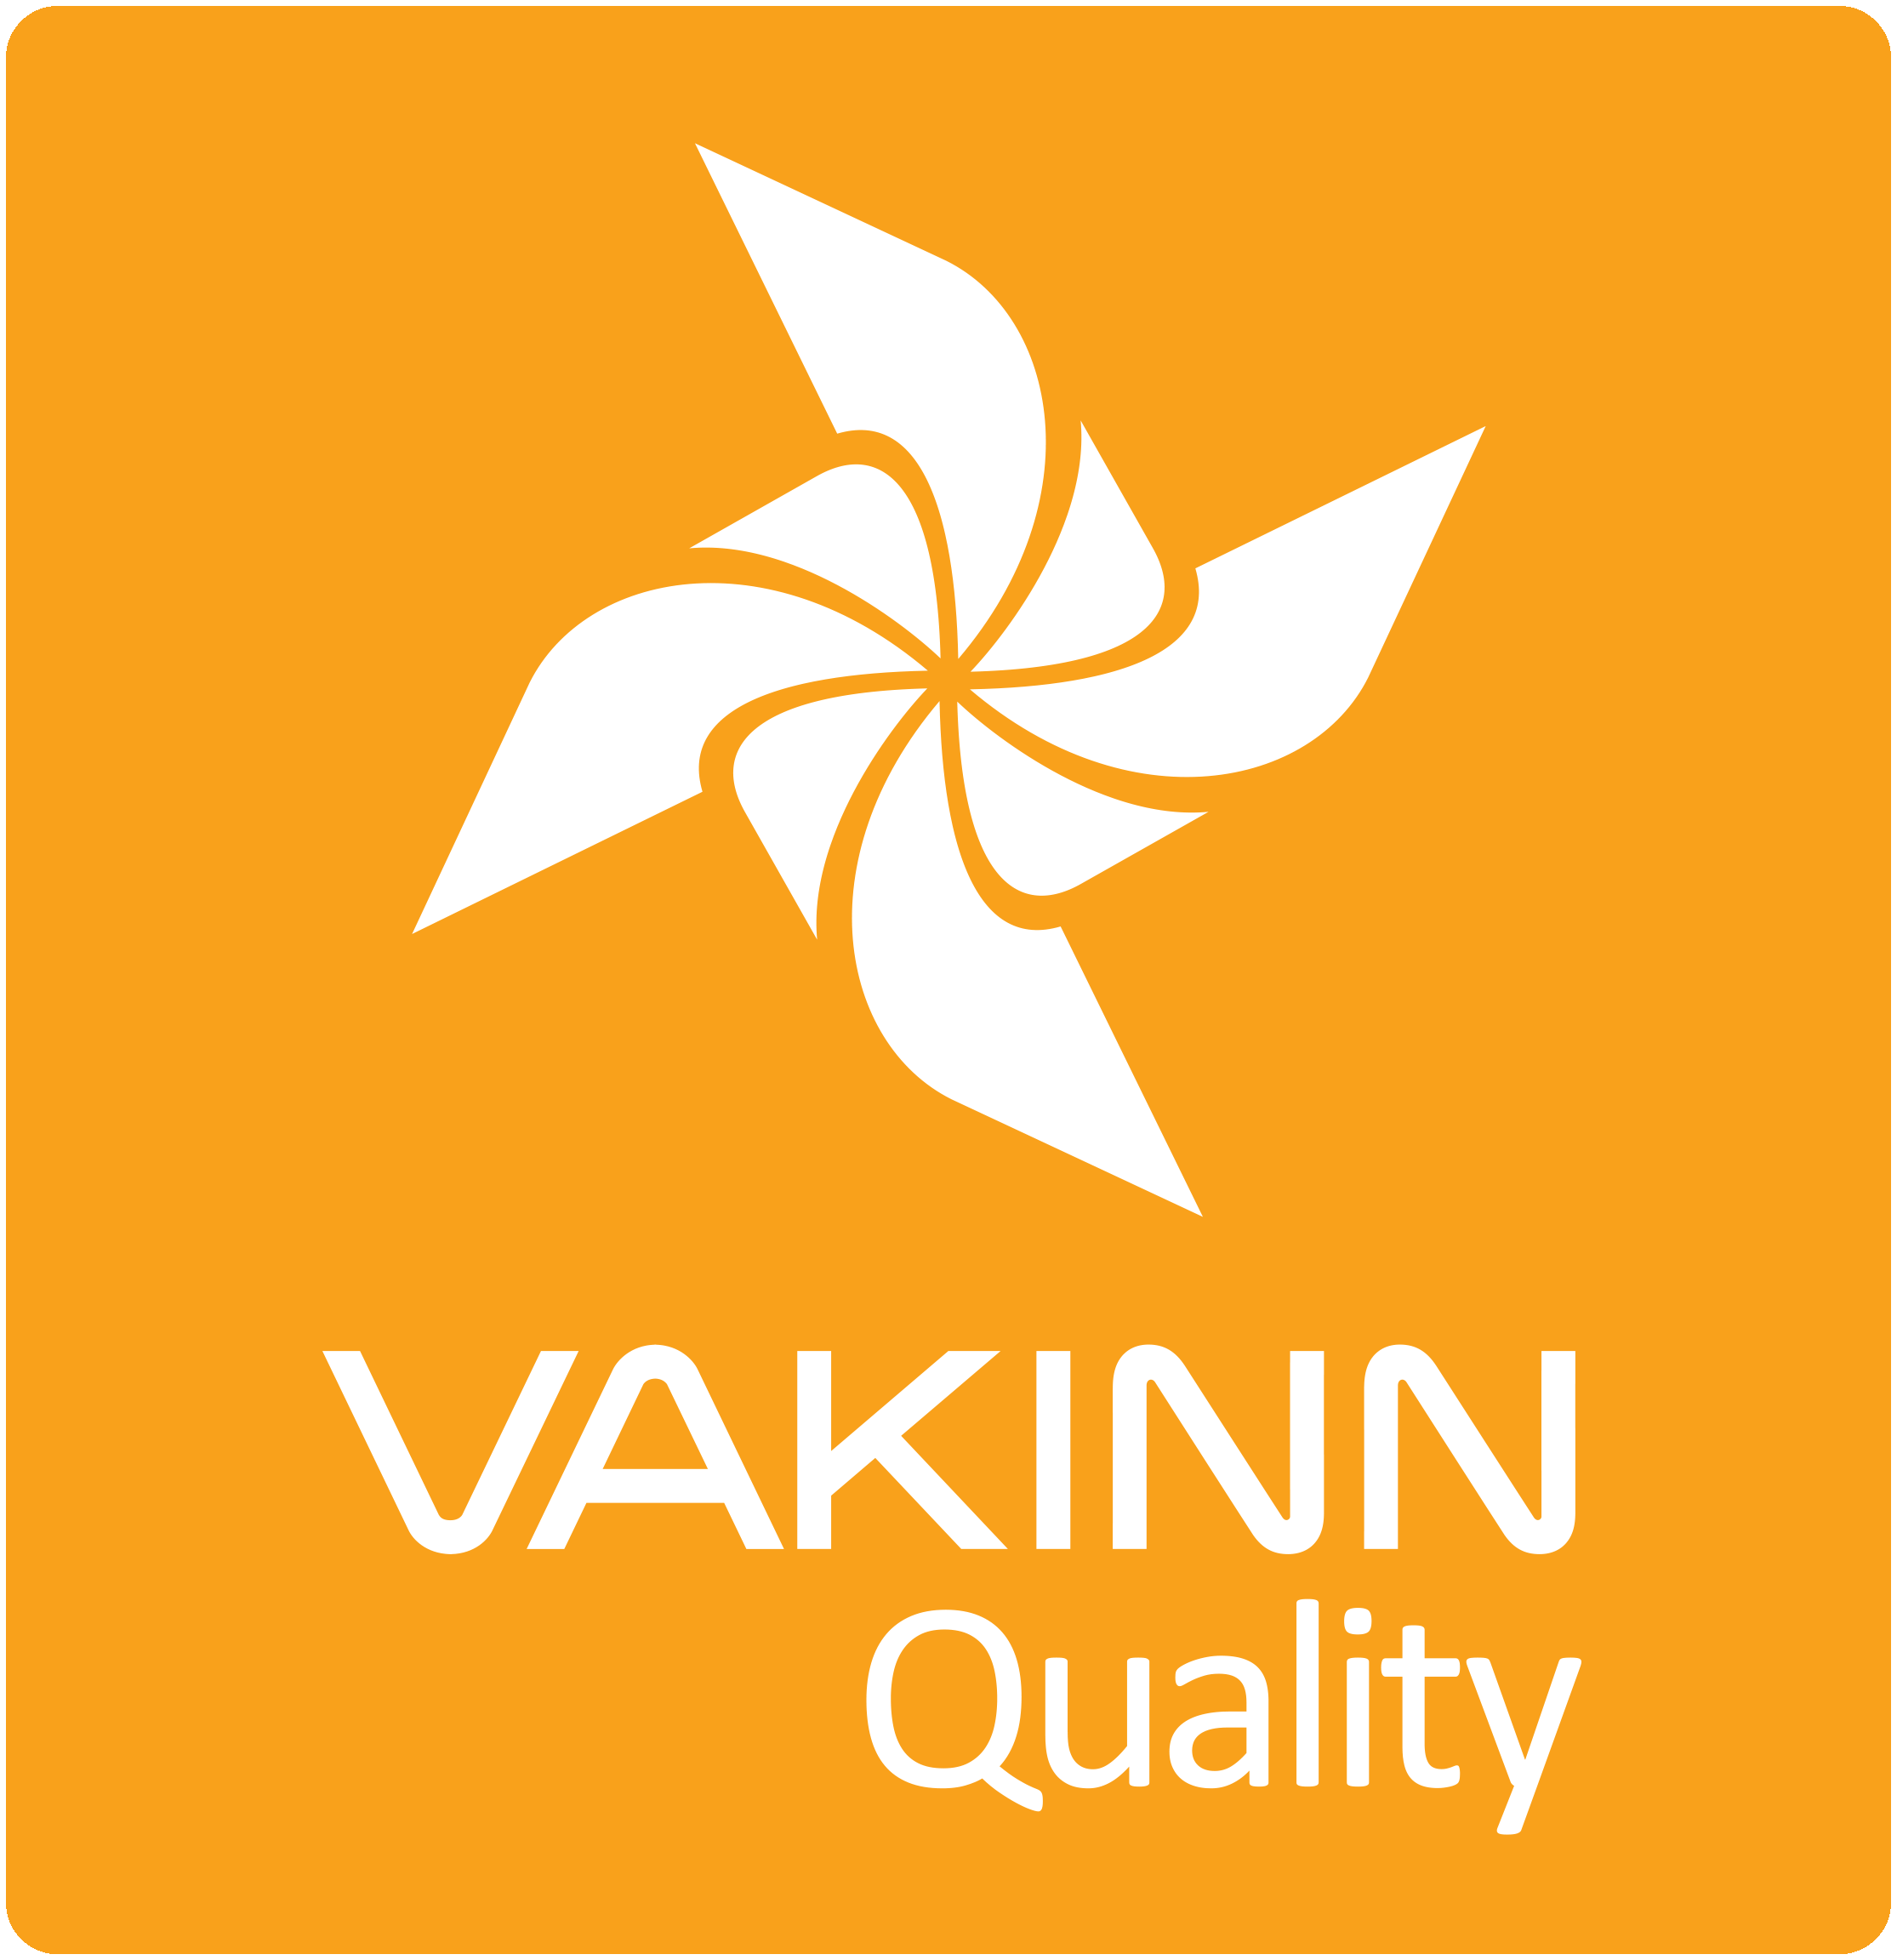

Vakinn Code of Ethics

All companies participating in Vakinn must confirm and abide by the Vakinn Code of Ethics:

1. The Company provides its customers with courteous and reliable service.
2. The company maintains and respects confidentiality and discretion in all customer relations.
3. The company is guided by professionalism, honesty and fairness in all communications and business
transactions.
4. The company treats all its customers with equal respect and consideration regardless of e. g. gender,
origin, culture, sexual orientation, religious preferences, age, social standing and physical aptitude.
5. The company ensures that all information provided to its customers is correct and that its
advertising provides a truthful and reliable impression of its services and facilities.
6. The company prices goods and services unambiguously and in compliance with current legislation.
7. The company makes an effort to answer all enquiries and requests professionally and efficiently.
8. The company guarantees a fair and prompt handling of complaints.
9. The company upholds and observes all laws and regulations pertaining to its operation.
10. The company ensures that its bookkeeping and accounting is conducted in a professional manner.
11. The company meets all its responsibilities towards employees by observing current laws and
collective labour agreements.
12. The company ensures that all its employees receive proper training and that working conditions are
appropriate.
13. The company ensures the safety of its employees and customers by means of professional work
practices and by maintaining high standards of facilities and equipment.
14. The company demonstrates responsibility towards Iceland’s nature, environment and society.
15. The company upholds the interests and reputation of Iceland as a high quality.

See specific quality criteria on vakinn.is.
One example of each is sufficient along with a confirmation that contracts are in place for all members of the staff and contractors. Personally identifiable information should be avoided
One example is sufficient along with a confirmation that such documents exist for all employees.
Photo/s required.
This does not refer to employees working in the office.
The criteria in chapter four apply to the bronze label of the environmental certification. If the company requests silver or gold certification, the applicable environmental criteria no. 300 must be fulfilled.
See checklist on vakinn.is
Photo / photos must be submitted along with written instructions.
Valid from 1.1.2024.

